The Impact of Rec N’ The Streets on Violent Crime in Seattle Parks
Prepared for: Seattle Parks and Recreation – Outdoor Activation and Mobile Recreation
Prepared by: Benjamin Scott
With methodological feedback from Dr. Plakias, Western Washington University
Research support: Edict Economics

Abstract
This paper evaluates the impact of Rec N’ The Streets (RNTS) programming on violent criminal activity in Seattle Parks & Recreation (SPR) spaces. RNTS is designed to activate low-equity parks through structured recreational and community-building programming. Using geospatially linked crime data and a panel regression framework, this study estimates the effect of RNTS programming on year-over-year changes in violent crime at the park level. Results indicate that RNTS programming is associated with a statistically significant reduction in violent crime, with robust inference confirmed through wild cluster bootstrap methods. RNTS programming reduces violent crime by approximately 0.49 incidents per park-season and consistently shifts crime trends downward, indicating both immediate reductions and more stable long-term safety outcomes.

Introduction
Rec N’ The Streets (RNTS) is a municipal program administered by the City of Seattle Parks and Recreation (SPR) under its Outdoor Active Recreation initiatives. The program deploys mobile, seasonal recreational programming—including sports, fitness classes, arts engagement, and youth-focused activities—into parks located in historically underserved and low-equity neighborhoods.
The central objective of RNTS is to activate public spaces that are otherwise underutilized or associated with negative externalities. By increasing legitimate use of space, RNTS aims to provide constructive opportunities for youth and community members, increase informal social surveillance through consistent community presence, and reduce the likelihood of criminal activity through deterrence and engagement.
This approach is consistent with environmental criminology frameworks, particularly routine activity theory, which posits that crime is less likely to occur when capable guardians are present and opportunities for offending are reduced. Within this context, RNTS can be interpreted as a structured intervention designed to increase guardianship and reduce environmental vulnerability.
The purpose of this paper is to evaluate whether RNTS programming achieves its intended effect by examining whether parks receiving RNTS programming experience reductions in violent crime relative to their own historical patterns.

Methodology

Data Collection and Construction
The analysis was developed through a multi-stage data construction process. First, violent crime data was obtained from the Seattle Police Department, consisting of incident-level records with timestamps and geographic coordinates. These records were filtered to include relevant violent offenses and then mapped spatially.
Each observation was assigned a standardized time structure. Years were indexed from 2020 (0) to 2025 (5), and observations were grouped into four seasons: winter (January–March), spring (April–June), summer (July–September), and fall (October–December).
Crime incidents were then spatially linked to Seattle parks using a proximity-based matching approach. A 100-meter buffer was applied, and each crime was assigned to the nearest park within that distance. This allowed for the construction of a panel dataset defined at the level of park, season, and year.
Within this panel, several key variables were constructed. Total crimes were aggregated for each park-season-year combination. A lagged variable representing total crimes in the prior year’s same season was created, allowing for the calculation of a year-over-year change variable. This change variable represents how crime has increased or decreased compared to the same time in the previous year. It serves as the primary outcome being studied in this analysis.
RNTS treatment status was then incorporated using program deployment data. Each park-season-year observation was assigned a binary indicator equal to one if RNTS programming was active and zero otherwise. Importantly, this treatment variable was adjusted to reflect actual RNTS activity timing, correcting earlier misalignment issues.

Data Limitations
A key limitation of the dataset is the potential underrepresentation of park-season observations with zero reported crimes, which may bias estimates toward higher-activity parks. Additionally, measurement error in spatial assignment may occur due to the use of proximity-based matching. While these limitations are unlikely to systematically bias the estimated treatment effect, they should be considered when interpreting the results.

Identification Strategy
This analysis identifies the effect of RNTS programming by exploiting within-park variation over time. Specifically, the model compares changes in violent crime within the same park across seasons in which RNTS programming is active versus seasons in which it is not. By including park fixed effects, the analysis controls for time-invariant differences across parks, such as location, infrastructure, and baseline crime levels. Season fixed effects further control for systematic seasonal fluctuations in crime. In addition, the dependent variable is constructed as a year-over-year change within the same season, which helps remove persistent seasonal patterns in crime.
This empirical approach is best understood as a generalized difference-in-differences design in a multi-period panel setting with staggered treatment exposure, where treatment varies across park-season observations, rather than a single common intervention onset. Following Callaway and Sant’Anna (2021), the identifying logic relies on comparing changes in outcomes over time between treated and untreated observations in settings with multiple periods and variation in treatment timing. In practical terms, the model asks whether violent crime in the same park changes when RNTS programming is active relative to comparable periods when it is not, while holding constant stable park characteristics and broad seasonal patterns. For non-technical readers, this should be interpreted as evidence of an immediate causal effect of RNTS on changes in crime during the treated park-season, not as proof of a permanent or fully long-run effect after treatment.
The key identifying assumption is that, absent RNTS programming, within-park crime trends would have followed similar seasonal trajectories. Accordingly, the design is strongest for estimating the short-run effect of RNTS activation on crime dynamics, rather than longer-term aftereffects that persist independently of ongoing programming.
Economically, this approach isolates the marginal effect of RNTS programming by comparing outcomes within the same park over time, rather than across different parks.

Regression Specifications
Two regression approaches were used to estimate the relationship between RNTS programming and changes in violent crime.
The primary estimating equation is a two-way fixed-effects panel specification:

ΔCrime_{it} = β · RNTS_{it} + α_{i} + γ_{s} + ε_{it}
where ΔCrime_{it} represents the year-over-year change in violent crime for park i in season-year t, RNTS_{it} is a binary indicator equal to one when RNTS programming is active in that park-season observation, α_{i} denotes park fixed effects, and γ_{s} denotes season fixed effects. Park fixed effects absorb time-invariant differences across parks, such as location, infrastructure, and baseline crime levels, while season fixed effects account for common seasonal fluctuations in crime.
Because RNTS exposure varies across park-season observations rather than beginning at a single common treatment onset, this specification is best understood as a baseline fixed-effects estimator in a generalized difference-in-differences-style panel setting. Accordingly, the coefficient on RNTS_{it} captures the average within-park change in violent crime associated with RNTS activation, conditional on stable park characteristics and common seasonal patterns. Consistent with the identification strategy outlined above, this estimate is interpreted as reflecting the short-run effect of RNTS during the treated park-season rather than a permanent long-run treatment effect.
A secondary inference procedure was implemented using a wild cluster bootstrap. Because the number of park clusters is relatively small, conventional clustered standard errors may be unreliable. The wild cluster bootstrap provides a more appropriate method for statistical inference in small-sample settings and serves as a robustness check on the significance of the estimated RNTS effect.
As a secondary specification, a signed logarithmic transformation of the year-over-year crime change variable was estimated to examine whether RNTS is associated with broader shifts in crime dynamics beyond the immediate level effects captured in the primary model. This specification is motivated by the possibility that RNTS may not only reduce violent crime in the treated park-season, but also contribute to more persistent downward movement or stabilization in crime trends over time. More broadly, this follows the use of alternative log-like transformations to reduce the influence of extreme values while preserving interpretable variation in outcomes that may cross zero (Burbidge, Magee, and Robb 1988; Ravallion 2017). The dependent variable is defined as:
Signed Log(Change YOY)_{it} = sign(Change YOY_{it}) · ln(|Change YOY_{it}| + 1)
The signed-log model preserves the direction of change while reducing the influence of extreme fluctuations. It is estimated using the same fixed-effects structure as the primary specification and is intended to assess whether RNTS is associated with a broader downward shift in crime dynamics, rather than only an immediate reduction in crime counts.

Results

Figure 1: RNTS Parks vs Citywide Crime Trends
To complement the regression results, Figure 1 compares the year-over-year percentage change in violent crime in RNTS-treated parks to the citywide average. This visualization provides a descriptive benchmark and illustrates whether RNTS parks are improving at a rate that exceeds broader city trends.
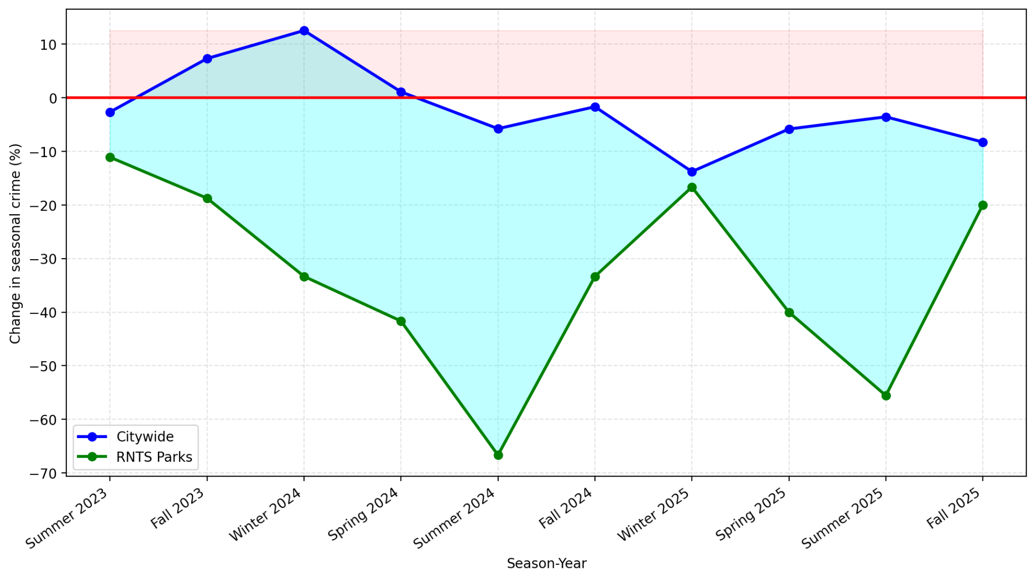

Figure 2: RNTS regression results
Figure 2 presents the primary regression results estimating the effect of RNTS programming on year-over-year changes in violent crime.
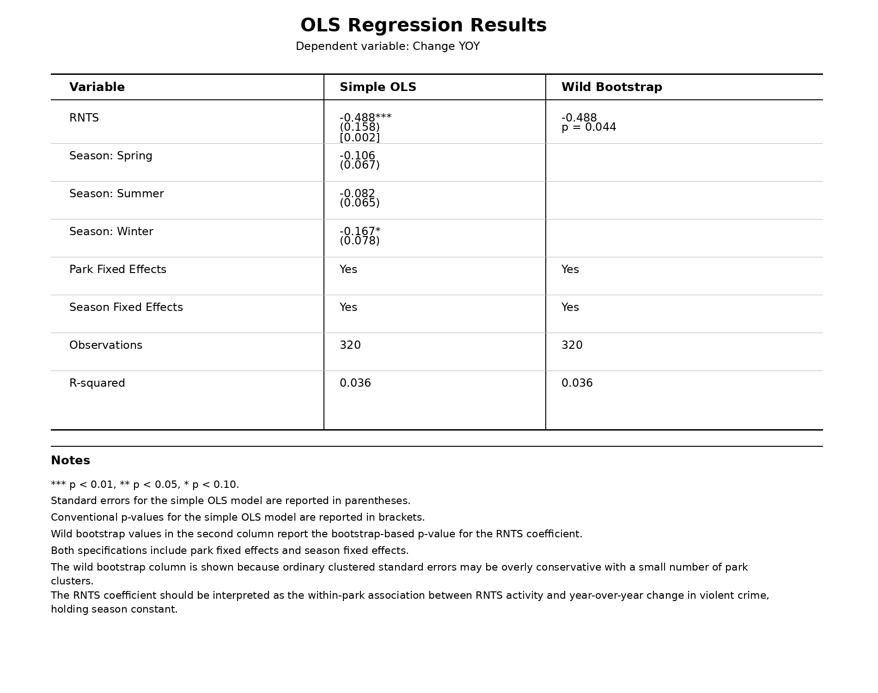
The estimated coefficient on RNTS is negative and statistically significant. This indicates that, on average, violent crime declines by approximately 0.49 incidents per park-season when RNTS programming is active, relative to comparable untreated periods within the same park. This result remains statistically meaningful under the wild cluster bootstrap procedure, reinforcing the robustness of the primary association.

Figure 3: RNTS Signed-log regression results

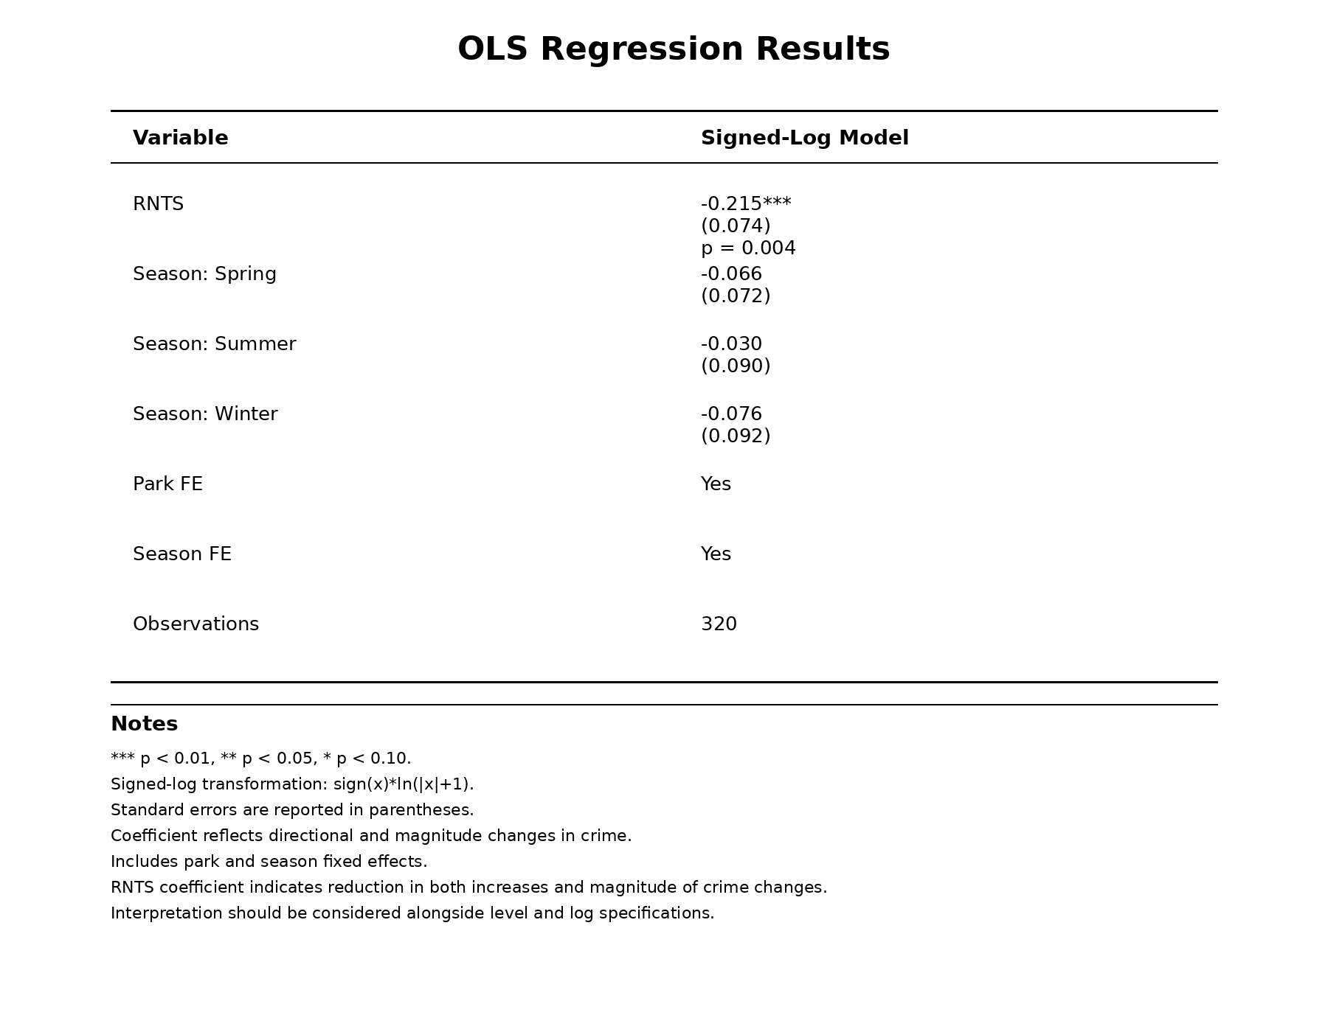

Figure 3 presents the signed-log regression results estimating the association between RNTS programming and broader changes in crime dynamics. The estimated RNTS coefficient remains negative and statistically significant, indicating that RNTS is associated not only with lower immediate crime changes, but also with a broader downward movement in the direction and magnitude of crime fluctuations across treated park-seasons.

Interpretation
Figure 2 presents the primary estimating results and should be interpreted as the primary estimate of the immediate effect of RNTS programming on violent crime during the treated park-season. In practical terms, the negative and statistically significant RNTS coefficient indicates that, on average, parks experience fewer violent crimes relative to the same season in the prior year when RNTS programming is active. This negative association is further reinforced by the wild cluster bootstrap inference procedure, which confirms that the result remains statistically meaningful even under a more conservative small-sample inference method. Because the model is identified from within-park variation over time and includes park and season fixed effects, this estimate is best understood as reflecting the short-run effect of RNTS activation rather than a permanent long-run treatment effect.
The magnitude of the estimated effect is substantively meaningful. Given the relatively low baseline level of violent crime observed across many parks, a reduction of approximately 0.49 incidents per park-season represents a notable improvement in public safety conditions. While the R-squared value is modest, this is not unusual in micro-level crime data, where a substantial share of variation is driven by localized and idiosyncratic shocks.
Figure 3 presents the signed-log specification, which is best interpreted as a secondary test of whether RNTS is associated with broader downward movement in crime dynamics beyond the immediate level effects captured in Figure 2. In this model, RNTS programming remains negatively and statistically significantly associated with changes in violent crime. Rather than isolating a separate long-run causal effect, this specification is more appropriately read as evidence that RNTS is associated with a broader downward and more stable pattern in crime dynamics across treated park-seasons.
For non-technical readers, Figure 2 answers the question of whether RNTS appears to reduce violent crime when programming is active, while Figure 3 asks whether RNTS also appears to dampen volatility and reinforce downward movement in crime trends. Taken together, the two figures suggest that RNTS is associated both with an immediate reduction in violent crime and with broader improvement in the direction and stability of crime patterns in treated parks.
For policymakers, this indicates that RNTS improves both the level and stability of public safety outcomes.

Potential Mechanisms
The observed reduction in crime associated with RNTS programming may operate through several related mechanisms grounded in environmental criminology and place-based intervention theory. First, consistent with routine activity theory (Cohen and Felson 1979), organized programming may increase the presence of capable guardians in park spaces by drawing participants, staff, and other community members into areas that might otherwise be underused, thereby reducing opportunities for violent offending. Second, RNTS may alter the social environment of parks by increasing legitimate use of space, strengthening informal social surveillance, and making criminal activity more visible and less attractive (Cohen and Felson 1979). Third, structured recreational programming may provide constructive engagement for youth and community members, reducing idle time while also building community familiarity and informal territoriality. This broader logic is consistent with evidence from place-based interventions showing that improving and activating public environments can reduce violence, crime, and fear in affected neighborhoods (Branas et al. 2018). In the RNTS context, the mechanism is not physical restoration alone, but the repeated activation of public space through visible, organized, community-centered programming.
These mechanisms collectively reduce the opportunity and incentive for criminal activity.

Policy Implications
The results of this analysis suggest that targeted recreational programming can serve as an effective complement to traditional policing strategies. Expanding RNTS to additional parks with similar characteristics is likely to produce comparable reductions in crime. Furthermore, prioritizing parks with historically higher crime levels may enhance the marginal impact of the program.

Conclusion
The findings of this study elucidate that Rec N’ The Streets programming plays a meaningful role in reducing violent crime in Seattle parks. By activating underutilized public spaces and increasing community presence, RNTS appears to alter the conditions under which crime typically occurs, leading to measurable reductions in year-over-year crime levels.
Taken together, the evidence suggests that RNTS is an effective intervention for reducing crime in targeted parks, with impacts that are both statistically significant and practically meaningful. Importantly, this result is reinforced by the signed-log specification, which indicates that RNTS not only reduces crime levels but also dampens fluctuations in crime. This suggests that the program contributes to both immediate reductions and more stable long-term safety outcomes.
From a policy perspective, this result highlights the effectiveness of non-enforcement-based interventions in addressing public safety concerns. Rather than relying solely on traditional policing strategies, RNTS demonstrates that structured recreational programming can serve as a complementary tool that reduces crime through engagement and environmental transformation.
The implications extend beyond the parks themselves. Reductions in crime within these spaces likely generate positive spillover effects for surrounding neighborhoods by improving perceptions of safety and reducing the likelihood of nearby criminal activity. These improvements can, in turn, contribute to local economic stability and increased community cohesion.
Additionally, by preventing crime before it occurs, RNTS programming may alleviate pressure on the Seattle Police Department by reducing the need for reactive enforcement. This suggests that investments in community-based programming can yield both social and fiscal benefits. From a cost-effectiveness perspective, these findings suggest that community-based activation programs may deliver substantial public safety benefits at relatively low cost compared to traditional enforcement strategies.
Importantly, RNTS-treated parks improve at a faster rate than broader citywide trends, indicating that the program contributes additional reductions beyond general declines in crime.
Several limitations should be noted when interpreting these results. First, the dataset may underrepresent park-seasons with zero reported crimes, which introduces a form of selection bias. Second, RNTS programming is not randomly assigned and may be targeted toward parks with higher baseline crime, raising concerns about treatment endogeneity. While the use of fixed effects and year-over-year differencing mitigates this concern, it cannot eliminate it entirely. Third, the relatively small number of park clusters (approximately twenty) limits the reliability of conventional clustered standard errors. Although a wild cluster bootstrap approach was used to address this issue, inference remains sensitive to the chosen method. Despite these limitations, the consistency of the estimated effects across specifications supports the robustness of the findings.
Overall, this study provides evidence that targeted activation of public spaces through programs like RNTS can be an effective and scalable strategy for improving public safety in urban environments. Policymakers should consider expanding programs such as RNTS as part of a comprehensive approach to crime reduction. These findings imply that investments in community-based activation programs can generate measurable public safety benefits at relatively low cost compared to traditional enforcement strategies. Because RNTS was not originally deployed as a crime-prevention intervention, treatment placement was not optimized around violent-crime risk. This means the observed association may reflect a conservative baseline rather than the program’s maximum public-safety potential. More intentional deployment in parks, seasons, or time windows with elevated violence risk could plausibly strengthen RNTS’s crime-abatement association, though this should be tested through future targeted evaluation.
As such, RNTS appears to be a scalable intervention supported by the empirical patterns documented in this study to improve urban public safety through community-based intervention. In simple terms, activating parks with consistent community programming makes them safer.

References
Cameron, A. C., & Miller, D. L. (2015). A Practitioner’s Guide to Cluster-Robust Inference. Journal of Human Resources.
Callaway, Brantly, and Pedro H. C. Sant’Anna. 2021. “Difference-in-Differences with Multiple Time Periods.” Journal of Econometrics 225 (2): 200–230.
Burbidge, J. B., L. Magee, and A. L. Robb. 1988. “Alternative Transformations to Handle Extreme Values of the Dependent Variable.” Journal of the American Statistical Association 83 (401): 123–127.
Ravallion, Martin. 2017. “A Concave Log-Like Transformation Allowing Non-Positive Values.” Economics Letters 161: 130–132.
Cohen, L. E., & Felson, M. (1979). Social Change and Crime Rate Trends: A Routine Activity Approach. American Sociological Review.
Branas, C. C., et al. (2018). Citywide cluster randomized trial to restore vacant land and its effects on violence. Proceedings of the National Academy of Sciences.
Seattle Police Department. Crime Data Portal.
City of Seattle Parks and Recreation. Rec N’ The Streets Program Overview.

Appendix A: Data Sources and Construction
This analysis draws on multiple data sources. Violent crime data was obtained from the Seattle Police Department’s publicly available crime dataset, which provides incident-level information including date, location, and offense type. Rec N’ The Streets programming data was compiled from Seattle Parks and Recreation schedules and internal program records.
The final analytical dataset was constructed through several intermediate steps, including spatial matching of crime incidents to parks using a 100-meter buffer, aggregation to the park-season-year level, and construction of year-over-year change variables. Additional processed datasets, including season-level crime totals and RNTS treatment indicators, were generated as part of the data construction workflow.
All intermediate and final datasets used in this analysis are available upon request.

