Targeted habitat acquisition for western gray squirrels in Klickitat County
  - Research paper | A staged investment in habitat protection and recovery
Prepared by Benny Scott | Edict Economics
Prepared for consideration by the Washington Department of Fish and Wildlife
Analysis snapshot 19 September 2026
Independent Edict Economics research.

Abstract
Targeted acquisition could place thousands of acres of potential western gray squirrel habitat under conservation control in Klickitat County, Washington. This study identifies whole-parcel portfolios under capital ceilings of $18 million and $50 million. Using the full historical occurrence record as conditional spatial evidence, the model selects 45 and 124 parcels, credits 2,055.06 and 3,306.38 acres of connected, remotely screened potential primary habitat, and estimates initial costs of $16.19 million and $44.98 million. A narrower 2018–2020 record scenario selects 15 parcels, credits 115.09 acres, and costs $7.18 million under either ceiling. The analysis combines county parcels and sales, Washington Department of Fish and Wildlife occurrence polygons, Forest Service canopy estimates, LANDFIRE vegetation, forest-practice applications, protected interests, and fire boundaries. It implements parcel normalization, transaction screening, land-price estimation, fractional raster measurement, habitat-component connectivity, mixed-integer portfolio selection, and fixed-portfolio stress testing. Recent public presence records can strengthen future parcel screening, although a complete contemporary occupancy surface remains unavailable in the sources located; these newer records were not inputs to the reported portfolios. Substantial price-prediction error and incomplete parcel-level ecological evidence favor staged purchase decisions. The proposed program starts with a compact survey and appraisal priority set, retains larger acquisition options, and releases funds against verified ecological benefit, transaction terms, and funded stewardship. Its policy rationale is durable control of strategically located habitat, rather than exclusive reliance on recurring protection decisions. Protection, avoided loss, and physical habitat expansion remain separate outcomes; population-survival benefits are not numerically estimated.

Executive summary
Klickitat County has a concrete opportunity to secure habitat for western gray squirrel recovery. Under the broader historical-record scenario, the $18 million ceiling supports a modeled portfolio of 45 parcels, covering 8,739.26 mapped acres, at an initial cost of $16.19 million. Within those parcels, the model credits 2,055.06 acres of connected potential primary habitat. The $50 million ceiling supports 124 parcels, covering 19,672.37 mapped acres, at $44.98 million, with 3,306.38 credited habitat acres. These larger portfolios show where a substantial protection program could take shape, provided current ecological value, prices, rights, and seller participation are confirmed.
The narrower 2018–2020 survey evidence identifies a focused starting point: 15 parcels, covering 3,649.31 mapped acres, at $7.18 million, with 115.09 credited habitat acres. Both ceilings select this same portfolio because the qualifying connected opportunity is exhausted before the smaller budget binds. This is the paper's “recent-record” scenario: the label refers to 2018–2020 records, not to newly located sightings. It describes the limits of this screen, not the limits of valuable habitat in Klickitat County. The broader portfolios use much older records and therefore require a wider verification effort.
Table 1. Base capital portfolios
Occurrence scenario | Parcels | Land acres | Initial cost | Credited acres
Recent records, either ceiling | 15 | 3,649.31 | $7.18 million | 115.09
Historical records, $18m | 45 | 8,739.26 | $16.19 million | 2,055.06
Historical records, $50m | 124 | 19,672.37 | $44.98 million | 3,306.38
All costs are modeled estimates, and each ceiling retains a 10 percent reserve. Credited acres are connected, remotely screened potential primary habitat—not newly created forest. “Recent records” in the numerical tables and archived figures means the 2018–2020 scenario; newer presence evidence is discussed separately and has not been used to rerun these portfolios.
Begin where the modeled return is strongest. Within the 15-parcel recent-record set, three parcels retain 50.4 percent of the credited habitat at a modeled cost of $925,788. Five retain 76.7 percent at $2.64 million; eleven retain 95.8 percent at $5.02 million. The first survey and appraisal targets are 04141300000600, 05161900000500, and 05163000000900. Their combined modeled efficiency is substantially better than buying the entire set, making them a practical first test of the acquisition strategy. Availability, title, and present use by squirrels remain to be established.
The immediate gain is more habitat under conservation control. Acquisition would protect existing forest structure and its recovery options; it would not instantly create new forest. Under an illustrative scenario in which acquisition prevents 20 percent habitat loss over 30 years, the historical $18 million and $50 million portfolios retain 411.01 and 661.28 more habitat acres, respectively, than the no-acquisition alternative. Those are conditional avoided losses, not forecasts of newly created habitat or measured changes in survival. Positive physical expansion would require a separately specified and priced restoration component.
Appraisals should determine the pace of spending. The land-price model uses 383 screened, single-document sale rows and has a spatially held-out median absolute percentage error of approximately 67 percent. Raising modeled land consideration by 50 percent pushes both fixed historical portfolios above their respective ceilings. Re-optimization produces smaller portfolios that fit the stressed budgets. This tests a higher-price scenario; it does not assign a probability to affordability.
The policy case is to secure important habitat for the long term, then manage it for recovery. Durable control can align land-use decisions with conservation across repeated management cycles, rather than leave every critical tract dependent solely on successive protection decisions. Acquisition still requires stewardship; its potential advantage is greater control over the habitat that matters, not freedom from future costs. The long-run comparison with regulation, easements, and management on already protected land is developed below.
Authorize a staged program, with purchases tied to evidence. First, verify the compact recent-record priorities and their habitat connections. Second, obtain current occupancy information and appraisals for the strongest historical-record candidates. Third, release funds for purchases or easements where the complete rights package, additional ecological benefit, and funded stewardship obligation are established. Keep unspent capacity available for better opportunities rather than allowing the budget to dictate the purchase list.

Why this habitat matters

A recovery opportunity in the Klickitat landscape
The western gray squirrel is native to Washington, unlike the introduced eastern gray squirrel familiar in many urban settings. WDFW identifies it as state endangered following its 2023 uplisting. The 2023 status review describes three principal regional populations: the Klickitat region, the North Cascades, and the southern Puget Trough. The Klickitat region extends into parts of Yakima and Skamania counties. This study confines purchase decisions to Klickitat County but retains surrounding spatial context, recognizing that the county line is an administrative boundary rather than an ecological barrier. [3, 6]
The need for habitat protection is substantial. WDFW identifies habitat loss and degradation, isolation, disease, and road mortality as important threats. Its South Cascades assessment found a 21.2 percent net decline in potential primary habitat between 1993 and 2017, with timber harvest the dominant identified disturbance. Wildfire dominated the corresponding North Cascades analysis. These regional findings establish the conservation concern; parcel-specific future loss still depends on local conditions and management. Not every harvest operation has the same ecological effect. [3, pp. 10–11]
Targeted acquisition responds to the part of this problem that land control can influence. Its strongest ecological case is a tract that preserves functioning habitat near occupied areas or secures a necessary connection between them. Cheap acreage alone is not enough: a large tract can contain little relevant habitat, while a small tract can protect an occupied core or a vulnerable link. The policy should therefore buy the rights that secure the greatest additional ecological contribution, not simply the greatest number of acres.
The recovery mechanism is straightforward: retain usable habitat, keep important routes connected, and preserve places where squirrels can continue to use the landscape. Where field evidence confirms those functions, acquisition offers a credible way to strengthen prospects for persistence. The present model measures the habitat opportunity, not the resulting percentage change in survival. Establishing that change would require population, movement, and demographic evidence beyond the parcel screen. [3–5]
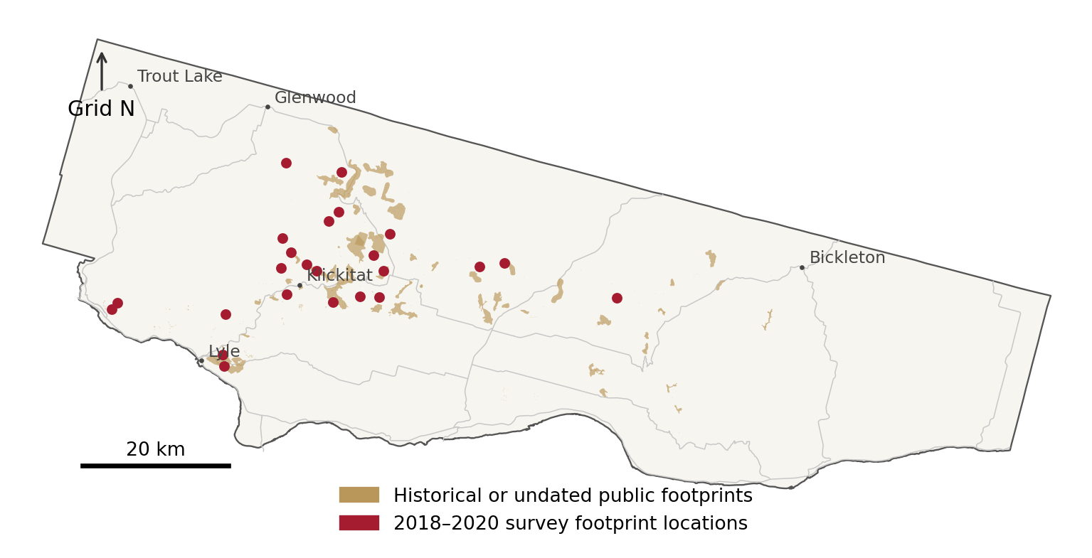
Figure 1. Study geography and occurrence evidence. Public source footprints are conditional evidence, not current occupancy. Sources: county mapping, WDFW, and study calculations. EPSG 5070.

Protecting forest structure, not just tree cover
WDFW's 2010 recommendations distinguish primary habitat from the larger secondary areas used for travel and seasonal resources. High-quality primary habitat is conifer dominated, with mature trees, a multilayered and interconnected canopy, and relatively little shrub cover. The recommendations describe 45–75 percent canopy cover and at least 75 percent conifers for high-quality primary habitat. Large nest trees and connected crowns matter alongside these stand averages. A useful acquisition must protect that structure, not merely a forest-colored area on a map. [5, pp. 3–5]
The satellite screen combines canopy cover, mapped conifer vegetation systems, and tree height to locate plausible primary habitat. Field inspection must establish the remaining conditions: trunk diameter, nest use, mast production, shrub density, and actual crown connections. Accordingly, “screened potential primary habitat” means acreage meeting the specified remote-sensing rules. It is neither a census of suitable habitat nor an estimated probability of occupancy, and it does not count squirrels.
Protecting that habitat also requires active stewardship. The fire consequences of tree removal depend on fuel arrangement, stand condition, treatment method, weather, and subsequent management; removing trees does not universally increase both fire likelihood and magnitude. Ownership cannot eliminate wildfire or disease. The acquisition program must therefore fund appropriate habitat management after closing, preserving the ecological purpose of the purchase as conditions change.

Recent presence evidence and the limits of the modeled record
Recent public presence records exist and can strengthen the evidence for nearby parcels, but a complete contemporary occupancy surface remains unavailable in the sources located. The most valuable next inputs are the precise recent sightings, the forthcoming repeat-survey results, and the UW/WDFW prioritization model. This updated assessment distinguishes a real opportunity to improve the evidence from a claim that the full present-day distribution is already known. [22]
The update does not change the inputs behind the published parcel counts. Those portfolios remain two distinct runs of the original WDFW extract: one using 2018–2020 records and one using the full historical record. New sightings can direct field checks and support a new, explicitly named scenario once their identity, date, location accuracy, and relationship to candidate habitat have been checked. They cannot retrospectively validate every parcel in an existing portfolio.
The WDFW public layer used in the model returned 940 features statewide, of which 869 intersect Klickitat County. All returned features carry the public-layer sensitive-data indicator N. Eight county records lack a source date. Among dated records, 806 are from 1994–1996, six more are from 1993, and only 24 are from 2018–2020. No later county source date appeared in this extract. These dates belong to the source features, not to the download, and the extract is not an inventory of every public observation source. [7; study extraction]
The 24 later features are buffered transect lines associated with hair-tube sampling. Older features predominantly carry a “Standard buffer” accuracy description. Neither that description nor the layer's “AS MAPPED” category identifies a precise nest coordinate. Likewise, a concentration of records can reflect survey effort, reporting practices, repeated observations, or location generalization rather than a dense present population.
WDFW's 2023 review reports detection-adjusted occupancy work from 2018–2020 and an estimated South Cascades occupancy of 0.44 within the sampled design. That is useful regional survey evidence, not a probability that can be assigned to each candidate parcel. The 24 public polygons are not independent abundance measurements, and the extract lacks the repeat visits and nondetections needed to refit an occupancy model. [3, pp. 9–10]
The UW/WDFW prioritization work is a further opportunity to build on agency research. The 2026 annual report to the Forest Practices Board identifies a University of Washington spatial-prioritization project and reports delivery of model parameters and code to WDFW on 21 July 2025. Obtaining the applicable model version and its spatial inputs would allow a documented comparison with this paper's independent acquisition screen. It has not been incorporated into these results. [23]
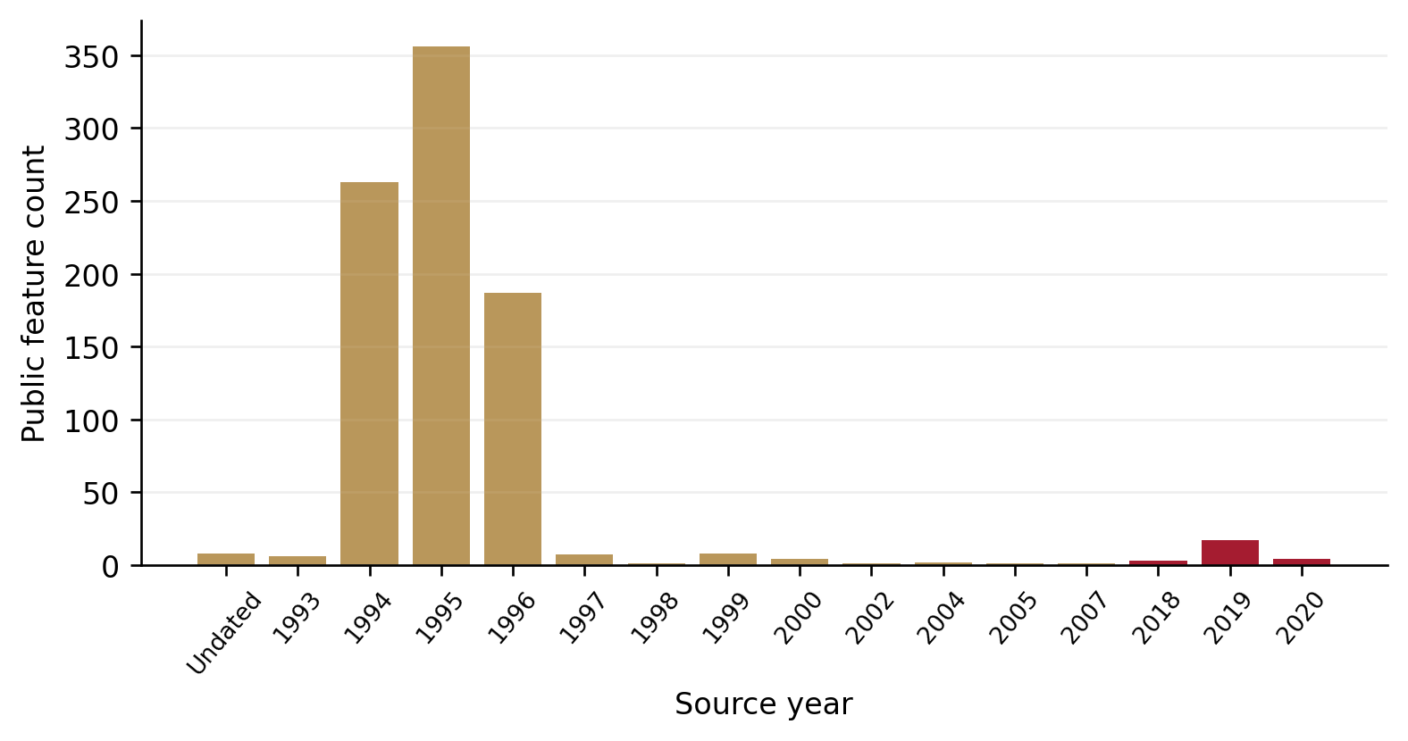
Figure 2. Source years of the 869 county occurrence features. Counts reflect public records and survey history, not population abundance. Source: WDFW public extract.

Policy objectives and decision criteria

The policy objective and its measurable counterpart
The policy question is whether targeted voluntary purchases or conservation easements can deliver ecological benefits cost-effectively while distributing costs fairly. This study focuses on habitat expansion and efficient acquisition within a wider recovery mission. WDFW's 2007 recovery plan also addresses viable populations, habitat protection and restoration, monitoring, research, and coordinated recovery work; acquisition is a contribution to those goals, not the agency's sole objective. [1, 2, 4]
The optimization follows the research protocol: choose whole acquisition units that maximize additional habitat within a budget. The spatial model can measure connected screened habitat. To evaluate additionality, it compares habitat retained with and without acquisition at the same future endpoint.
When every unit receives the same positive avoided-loss fraction, maximizing additional retained habitat selects the same portfolio as maximizing connected screened acreage. That simplifying assumption makes the current screen usable. Parcel-specific effects, when available, must replace the common fraction and trigger a new model run.
maxi​xiΔHi subject to i​xiCi<B.
In plain language. The model chooses a package of whole parcels to maximize its habitat total while keeping costs below the ceiling. For parcel i, xᵢ is the yes/no purchase switch, ΔHᵢ is conditional additional habitat, Cᵢ is cost, and B is the budget. Σ means ‘add across parcels.’ The executed selection uses connected screened acreage; conditional additional retention uses the stated avoided-loss assumption.
$$x_{i}∈\{0,1\}, B∈\{18,000,000, 50,000,000\}.$$
In plain language. Each xᵢ can be only 0 (do not buy) or 1 (buy the whole unit). B is set to $18 million or $50 million in separate comparisons. A larger ceiling does not require the model to spend the additional money.
i​m​ximCim,s0≤B−RB−0.01.
In plain language. Add the initial cost C⁰ of each selected parcel i and rights option m under cost scenario s. The total must leave reserve R_{B} untouched and stay one cent below the remaining budget. Here, x selects an option; the executed model prices only fee-simple purchase and reserves 10% of B.
Here xᵢ selects whole acquisition unit i, ΔHᵢ is its conditional additional habitat, Cᵢ is the applicable cost, B is the ceiling, and R is the reserved amount. Implemented benefits use connected screened acreage under a common avoided-loss fraction.
The $18 million and $50 million ceilings are analytical scenarios specified for this study, not verified appropriations. Each capital run sets aside a 10 percent reserve, leaving strict acquisition-and-initial-work limits of $16,199,999.99 and $44,999,999.99. The reserve is a planning assumption rather than an observed transaction expense. The budget constraint uses integer cents. Annual stewardship is reported separately, and an additional set of runs charges the same ceiling for capital plus the present value of 30 years of assumed management.

What counts as an ecological gain
Four accounts keep the policy's gains clear. Land acquired is the size of the rights package. Newly controlled habitat is existing screened habitat brought under conservation rights. Avoided loss is habitat retained because of the intervention, compared with no acquisition at the same endpoint. Physical expansion is habitat added beyond what exists today. These accounts describe different consequences; they must not be added together as though the same acre delivered several separate acreage gains.
Table 2. Ecological accounting definitions
Account | Meaning | Executed treatment
Land acquired | Whole mapped acquisition unit | Paid once; all acres reported
Newly controlled habitat | Existing habitat brought under rights | Connected screened acres only
Avoided loss | Action minus no-action habitat at endpoint | 0, 10, 20, or 35 percent illustrative retention difference
Physical expansion | Future habitat minus habitat today | Zero in the acquisition-only hold-structure model

The study's economic result is a cost-effectiveness comparison in a specified habitat unit. Acres per million dollars are not a benefit-cost ratio. Biodiversity is not monetized, and extinction-risk reduction is not estimated. Financial feasibility, ecological verification, and social value are therefore separate tests: a portfolio can fit the budget without yet satisfying the other two.

The proposed acquisition program

Start with a focused purchase pathway
Establish a voluntary acquisition program that begins with the three recent-record priority parcels and expands as current ecological evidence improves. Fee-simple purchase is the modeled instrument because the available sales concern land transactions. Easements remain a practical alternative where an owner can retain compatible uses while surrendering the rights that threaten the relevant habitat. Their prices must reflect the actual restrictions, retained rights, management obligations, monitoring access, and enforcement provisions—not an assumed fraction of fee-simple value.
The first priority set consists of 04141300000600, 05161900000500, and 05163000000900. Together, they retain 57.97 acres of connected screened habitat in the recent-record graph at a modeled acquisition-and-initial-work cost of $925,788. They are one analytical priority set, not a presumed seller bundle.
The set was identified by examining every subset of the 15-parcel maximum-habitat portfolio and finding the lowest modeled cost that preserves at least half its connected benefit. Its optimality is specific to that restricted comparison; it is not a separately certified countywide procurement optimum.
The five-parcel option adds 03112000000100 and 05162100000100, retaining 88.24 screened acres for approximately $2.64 million. Its incremental cost per additional habitat acre is much higher than that of the first group. Verification may change habitat estimates, rights, or prices, so the option deserves its own decision rather than automatic inclusion because funding remains.
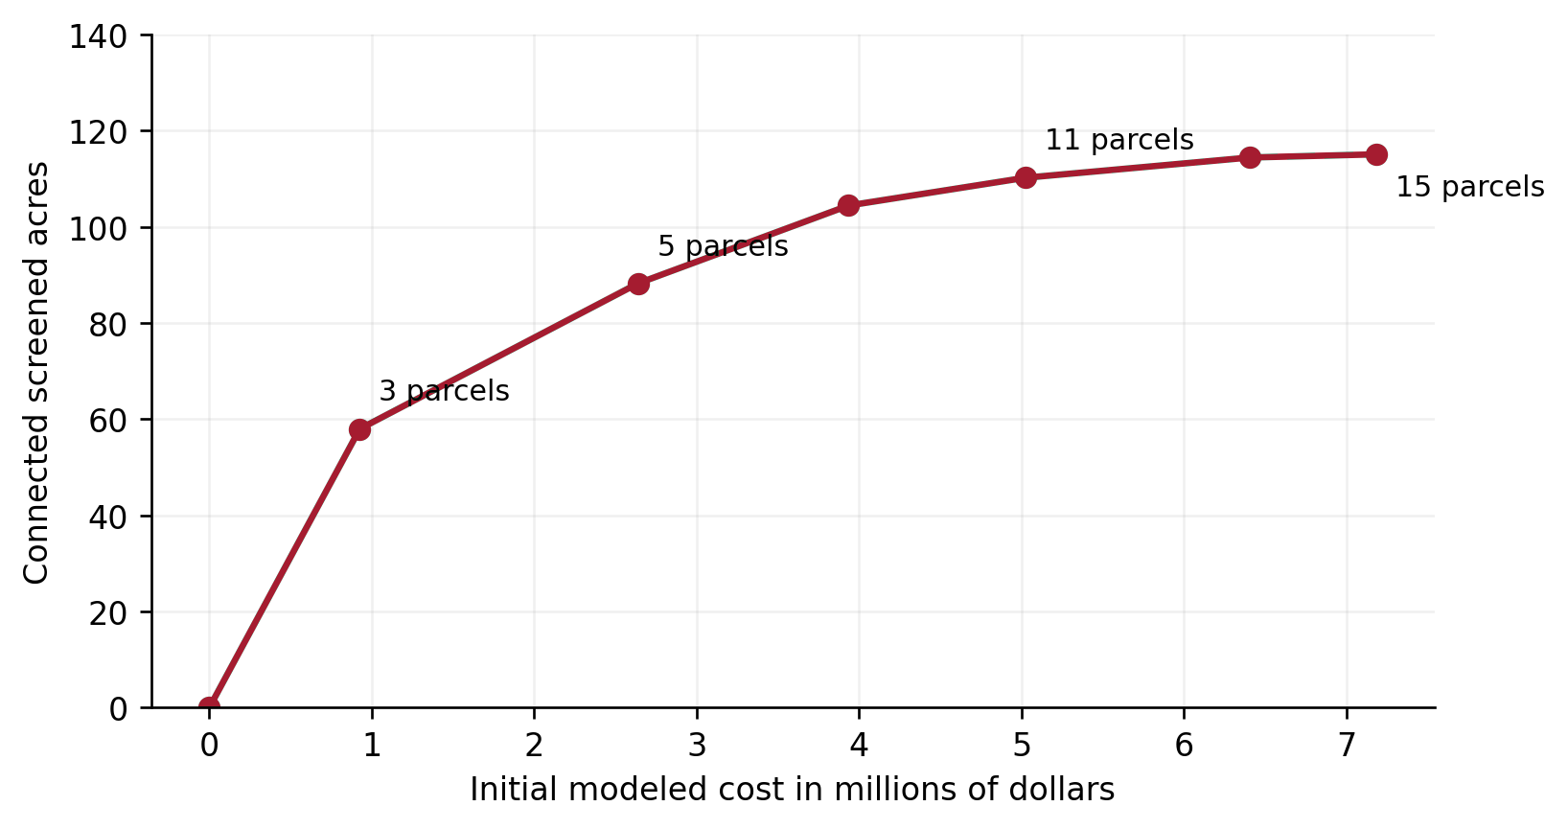
Figure 3. Cost and credited habitat along the exhaustive frontier restricted to the 15 selected recent-record parcels. Paths are rechecked for every subset. Source: study calculations.

Geographic priorities and parcel identities
The recent-record schedule identifies the exact county parcel numbers, mapped acreage, modeled initial costs, and credited habitat. Leading zeros are retained. Every row represents the complete mapped parcel and its modeled fee-simple purchase, even where only part contributes habitat. A required multi-parcel seller package must replace the relevant rows as one indivisible unit, with its full price charged once and the portfolio re-optimized.
Table 3. Complete recent-record base shortlist
Map ID | County parcel ID | Land acres | Initial cost | Credited acres
R009 | 03112000000100 | 607.53 | $1,322,651 | 21.93
R012 | 03112900000100 | 318.80 | $1,123,031 | 2.17
R015 | 03112900001000 | 22.71 | $616,790 | 2.94
R037 | 04131100000200 | 326.14 | $487,424 | 8.12
R055 | 04141300000600 | 39.49 | $425,255 | 20.97
R066 | 04142400000300 | 403.27 | $727,737 | 4.87
R118 | 05161600000000 | 648.41 | $402,757 | 0.16
R121 | 05161900000200 | 404.44 | $376,906 | 0.51
R124 | 05161900000500 | 40.45 | $219,771 | 13.36
R126 | 05161900000700 | 20.21 | $191,153 | 0.00
R128 | 05162100000100 | 565.36 | $389,831 | 8.34
R135 | 05163000000500 | 40.12 | $221,086 | 4.74
R136 | 05163000000900 | 116.47 | $280,763 | 23.64
R138 | 05163000001200 | 81.33 | $256,925 | 1.79
R148 | 05181900000800 | 14.59 | $140,053 | 1.56
The three first-stage parcels are 04141300000600, 05161900000500, and 05163000000900. Figures and electronic schedules use the same map IDs. Rounded rows may differ slightly from exact totals.
A parcel's contribution depends on the habitat path that remains active in the selected portfolio. A unit with little primary habitat can connect a larger component to an occurrence root. Conversely, buying a parcel does not make every disconnected habitat patch on it eligible for credit. The schedule therefore separates connected credited acres from total screened habitat. Contributions belong to their specific portfolio run; they are not standalone biological appraisals and cannot be summed across incompatible runs.
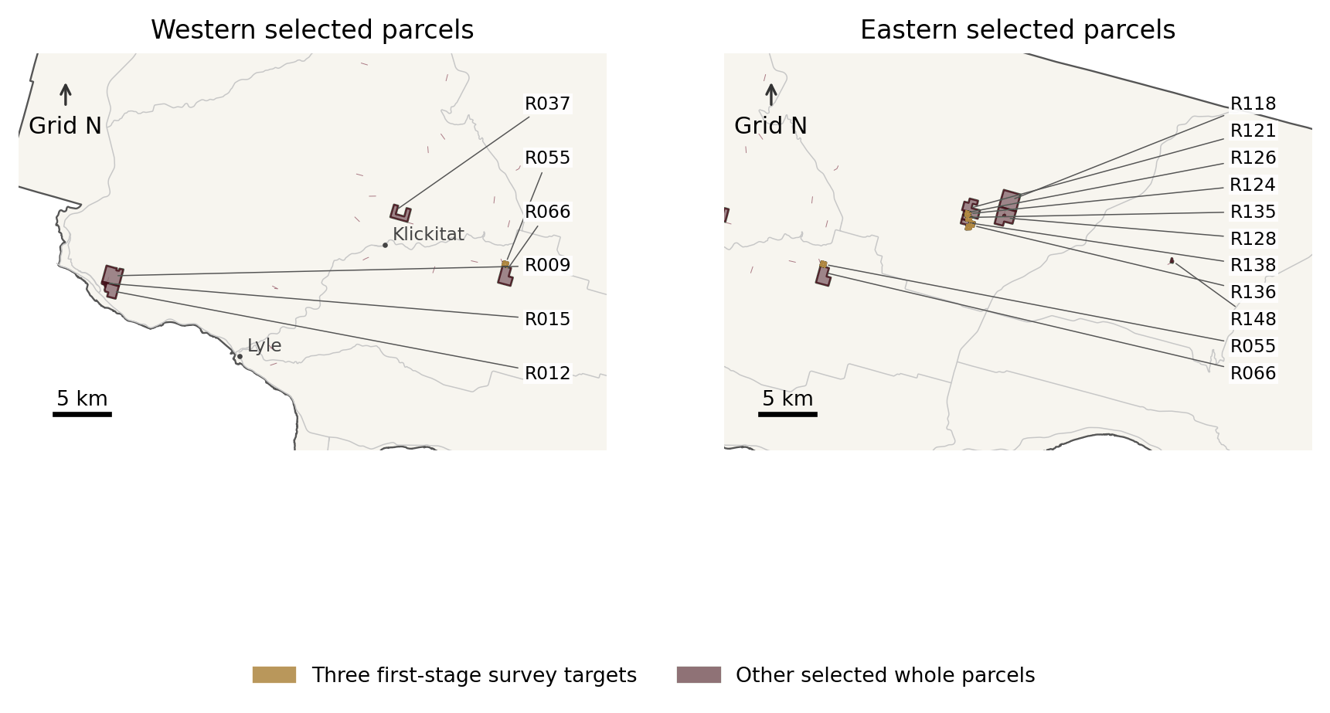
Figure 4. Recent-record whole-parcel priorities. Gold identifies the three first-stage survey targets. R codes join to the parcel schedule. The two panels overlap geographically. Source: county mapping and study calculations. EPSG 5070.

What the larger budgets could secure
The historical-record scenarios test the larger opportunity: where should spending concentrate if the full public occurrence record remains relevant to current habitat use? Prices, vegetation rules, financial assumptions, and connectivity mathematics stay the same. Allowing all county occurrence features to define the search footprint and possible roots expands the candidate universe from 155 to 902 parcels and root-reachable screened habitat from 115.09 to 3,788.43 acres, before imposing the budget.
Within that broader screen, the $18 million alternative selects 45 whole parcels and the $50 million alternative selects 124. Their maps and complete schedules identify where surveys and voluntary negotiations could support a larger conservation program. Historical-only sites remain conditional on updated ecological evidence; their inclusion is not a finding of current occupancy. The recent-record and historical-record totals answer different evidence questions and must remain separate rather than being blended into one expected-value estimate.
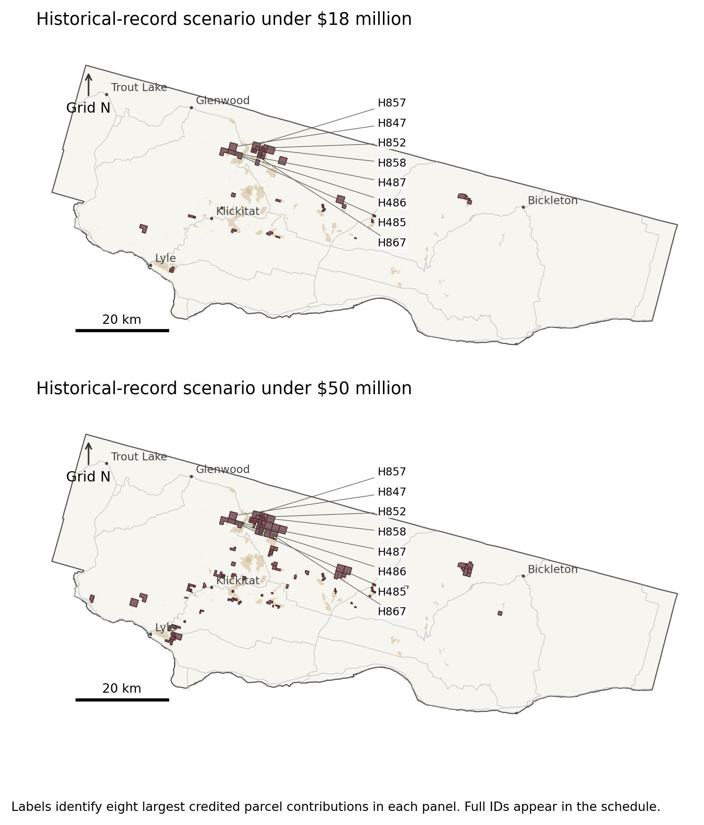
Figure 5. Historical-record base portfolios. Labels identify the eight largest credited parcel contributions in each panel; all selected parcels appear in the electronic layers and schedule. Source: county mapping and study calculations. EPSG 5070.
Moving from the broader $18 million portfolio to the broader $50 million portfolio adds 1,251.32 connected screened habitat acres. This is a substantial additional protection opportunity, but each added dollar yields less habitat than the smaller portfolio's average. The result shows diminishing opportunities within the screen, not a monetary valuation of habitat. The main comparisons solve each ceiling independently; a separate staged run requires retention of the smaller portfolio so that a purchase sequence does not silently determine the primary result.

Turn candidates into defensible transactions
Before recommending a purchase, WDFW or its implementing partner should confirm current squirrel use or a documented habitat-connection role, inspect the structural conditions that remote sensing cannot measure, and establish the actual rights package. Independent appraisal, title and access review, and a seller-participation record replace the provisional price and availability assumptions. Existing easements and management obligations require review of the recorded terms, not inference from a protected-area map.
All numerical portfolios assume hypothetical seller willingness. No offers were obtained or transactions negotiated, and an assessor record conveys no owner consent. A run restricted to documented willing sellers would therefore have no confirmed offers to select at present. The next task is to establish participation, not to infer that the owners are unwilling.
Retain the discretion to decline a tract after verification and redirect funds to a better purchase, an easement, management on existing conservation land, or a high-value survey. The $50 million ceiling is an option for verified expansion, not a spending target. Its value lies in the ability to act on additional defensible opportunities as they emerge.

Economic and distributional effects

Pay for protection—and its continuing care
Modeled initial cost includes estimated land consideration, $15,000 per unit for due diligence and legal work, 2 percent for closing, and $25 per assessor acre for initial site work. These are explicit planning allowances, not quotations. The site-work allowance earns no restoration-acreage credit and does not establish that habitat can be restored for $25 per acre. Particular survey or engineering needs could exceed it substantially.
$$C_{im}^{0}=P_{im}+D_{im}+T_{im}+R_{im,0},$$
In plain language. Initial cost C⁰ is the land-rights price P, plus due diligence D, transaction costs T, and initial site work R₀. The i and m subscripts identify the parcel and rights option. The screening allowances are $15,000 per unit, 2% of land price, and $25 per assessor acre. The site-work allowance earns no restoration credit.
$$PV\left(C_{im}\right)=C_{im}^{0}+\sum_{t=1}^{T}{\frac{M_{im,t}+R_{im,t}}{{\left(1+r\right)}^{t}}}.$$
In plain language. PV puts the purchase and later care on one present-value basis. Start with initial cost C⁰. For each year t through horizon T, add management M and later restoration R after dividing by (1 + r)ᵗ, where r is the real discount rate. The lifecycle runs price 30 years of the stated management allowance; this general formula does not mean a separate restoration program was priced.
P is rights-consistent consideration; D and T are due-diligence and transaction allowances; R₀ is initial work; M and R are later management and restoration expenses; r is the real discount rate; and T in the summation limit is the time horizon. The executed screening allowances are specified in the surrounding text.
Stewardship is modeled at $25 per assessor acre each year for 30 years, with real discount-rate comparisons of 0, 3, and 5 percent. The annual allowance is constant in analysis-year purchasing power. Historical nominal sales are translated to the September 2026 analysis date through the price model's estimated sale-time covariate, not a consumer-price-index adjustment. The rates and management amounts are scenario settings rather than measured stewardship costs or mandated government discount rates.
Table 4. Stewardship exposure of the fixed base portfolios
Portfolio | Annual assumption | 30-year PV at 0% | PV at 3% | PV at 5%
Recent records, either ceiling | $91,428 | $2.74 million | $1.79 million | $1.41 million
Historical records, $18m | $217,277 | $6.52 million | $4.26 million | $3.34 million
Historical records, $50m | $491,321 | $14.74 million | $9.63 million | $7.55 million
Assumed $25 per assessor acre annually, constant real amount. These values are sensitivity allowances, not management plans or contractor quotes.
For the full recent-record portfolio, the annual management allowance is approximately $91,429, with a 30-year present value of $1.79 million at 3 percent. Capital plus that obligation remains below the smaller scenario's net ceiling. Stewardship is more consequential for the historical portfolios: charging its present value against the same ceiling reduces achievable connected habitat. A capital program should therefore identify a separate management funding source or use the lifecycle-budget alternatives reported in Appendix C.

Opportunity costs and the treatment of compensation
Three economic ledgers must remain separate: government cash outlay, real resource use, and distributional transfers. The acquiring body pays for a parcel, and the seller receives that payment. Social opportunity cost depends on the rights acquired and the uses displaced. Adding the purchase price to every future timber return already capitalized into that price would generally double-count overlapping land value. Appraisal, legal work, restoration labor, and ongoing management still consume real resources. [17]
For displaced timber production or development, the relevant economic measure is forgone net value, not gross sales. A permit indicates proposed activity; it does not establish a harvest date, timber volume, or realized economic loss. Parcel timber cruises, operating margins, owner harvest schedules, and relocation decisions are absent from the present data. Forgone profits, employment multipliers, and local-income impacts consequently remain unestimated.
Acquisition may also retain ecological functions and recovery options that are not traded in markets. This paper reports those consequences in physical or qualitative terms. No willingness-to-pay survey, local benefit transfer, or species-viability model was estimated. The results support a relative cost-effectiveness assessment, but not a claim of positive monetary net benefit.

Who benefits and who may bear costs
Participating owners receive compensation in exchange for specified rights. Nonparticipants may experience little direct effect, although neighboring management or land-market conditions could change. Displaced harvest could affect timber workers and contractors, while restoration and stewardship could support different work. These are plausible distributional channels, not measured job gains or losses; their scale and location depend on the eventual transactions and management contracts.
Each transaction also needs a fiscal estimate for Klickitat County and the affected taxing districts. Designated forestland assessments can be lower than market-oriented values, so the county land-value field is not an acquisition-price proxy. State-owned game lands may qualify for the payment-in-lieu framework in RCW 77.12.203, subject to its conditions and the county's election. The fiscal assessment must check actual tax codes and applicable arrangements rather than assume either total loss of property taxes or dollar-for-dollar replacement. [18, 19]
Tribal lands and interests require a different process from an ordinary private-market purchase. The automated screen excludes identified Tribal and Native American holdings from the private candidate universe, but it neither substitutes for consultation nor identifies every relevant interest. Traditional uses, access, ecological knowledge, cultural resources, and off-parcel effects should be addressed through appropriate government-to-government engagement before the implementing agency fixes the acquisition design.
Table 5. Fiscal and economic incidence
Party or account | Likely channel | Required evidence
Participating owners | Voluntary payment and foregone retained rights | Title, willingness, appraised rights value
Public acquisition fund | Consideration, transaction work, reserve and stewardship | Appropriation, grant terms, lifecycle plan
County and districts | Potential tax-base change or applicable replacement payment | Parcel tax codes, actual levies, legal eligibility
Workers and local firms | Changed timber activity and habitat-management demand | Business evidence and displacement; no multiplier inferred
Tribal governments | Sovereign interests and culturally important resources | Direct government-to-government engagement
Society | Habitat retention and real opportunity costs | Additionality, resource costs and external effects

Test the purchase list before committing funds
A 50 percent increase in land consideration raises the fixed historical portfolios' initial costs to approximately $23.85 million and $66.29 million, exceeding their original ceilings. Re-optimizing under those higher prices instead selects 30 and 85 parcels, with 1,666.41 and 2,857.63 credited habitat acres. These are affordable alternative designs under the specified stress, not evidence that completed purchases could later be rearranged without cost.
Because the fitted price model has large residual variation, the paper also reports a 2.5-times land-consideration stress, without assigning it a probability. Price shocks are applied jointly across selected land. This avoids manufacturing a diversification benefit by assuming unrelated parcel errors. Habitat thresholds are likewise changed consistently across the landscape; thousands of neighboring pixels do not make shared ecological or measurement uncertainty disappear.
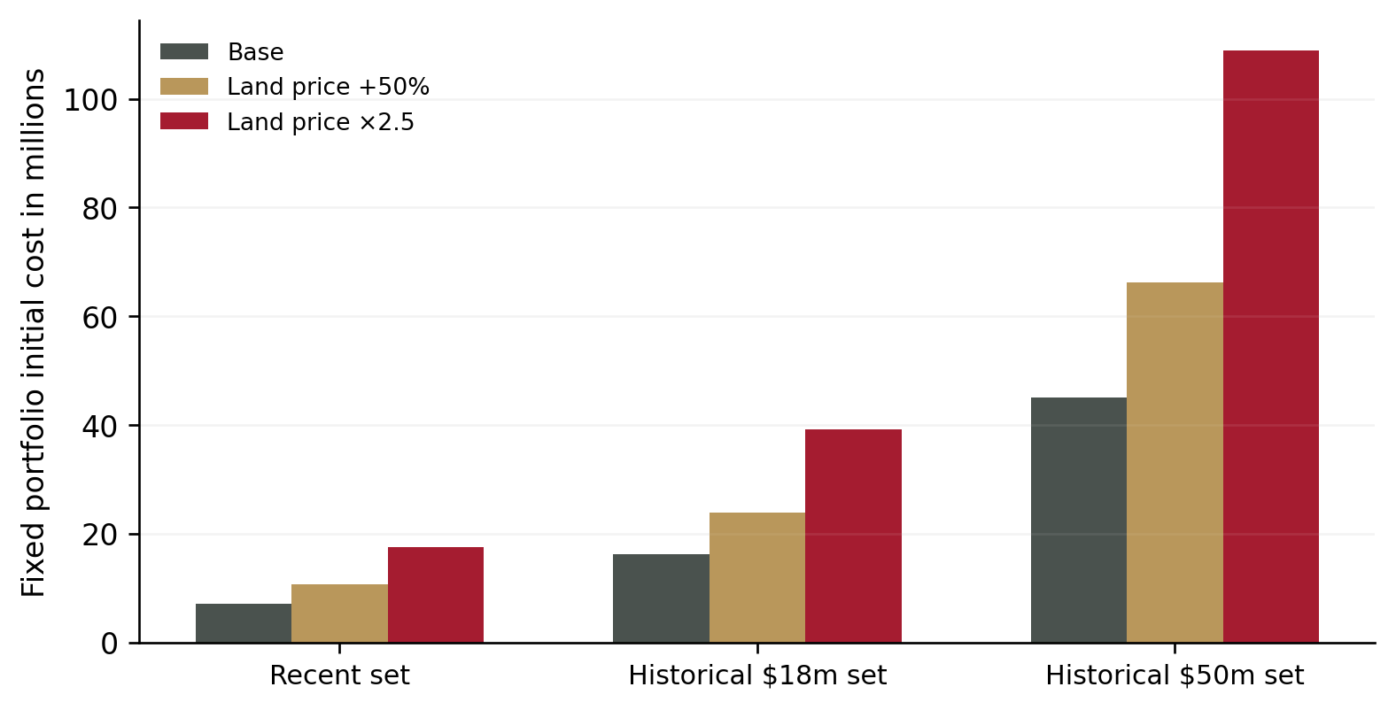
Figure 6. Initial costs of the fixed base portfolios under alternative land consideration. Transaction and initial-work allowances retain their stated formulas. Scenarios are not confidence intervals. Source: study calculations.

The long-run case and the alternatives

Management and restoration on land already controlled
Acquisition should earn its place alongside the alternatives. Management on existing conservation land can avoid a purchase payment, but existing control alone does not establish adequate habitat quality. Thinning patterns, retention of large trees and mast sources, invasive vegetation, and fire management may change habitat function. Compare those interventions with purchases on the same additional-outcome basis. Comparable site prescriptions, treatment costs, and response evidence are not available here, so a management-only alternative is not quantified and acquisition is not presumed superior merely because it has been modeled in more detail.
Restoration offers a route to physical habitat expansion, whereas acquisition can secure existing structure while that restoration develops. Mature habitat may take years or decades to emerge. A defensible restoration alternative must specify starting vegetation, treatments, recruitment and growth, maintenance, failure risk, and the time at which habitat criteria are met. Counting newly planted acres as immediately suitable would overstate returns and could change the preferred portfolio. The acquisition-only screen therefore credits no new physical habitat at purchase.

Easements and voluntary agreements
An easement can leave land in private ownership, retain compatible economic uses, and protect the habitat functions that matter. Its value depends on changing the no-acquisition baseline and sustaining enforceable obligations. An inexpensive easement that leaves the relevant harvest risk untouched may add little protection. A well-designed one could secure the required habitat for less public outlay than full ownership. Before-and-after appraisals and actual deed terms are needed to price that comparison; neither is available for these parcels.
Shorter-term voluntary agreements can bridge the period needed for surveys and appraisals, especially where a decision is time-sensitive. Their habitat credit must reflect duration, renewal risk, and potential loss after expiry. A short agreement cannot automatically receive a 30-year benefit. Assign option payments and interim management costs to the actual transaction rather than applying an undifferentiated percentage to every parcel.

Durable acquisition versus recurring protection decisions
A spatial tree-retention policy illustrates the regulatory alternative. Rather than rely only on stand-wide tree counts, a policy could address retained nest and food trees, canopy cover, and the arrangement of connected crowns or movement routes. The precise requirements would need ecological support and a review of applicable legal authority. No numerical spacing rule or tree quota is proposed or assumed to be current law in this analysis. [5; policy illustration]
Acquisition offers a different form of durability. On a verified high-value tract, purchasing the relevant rights can place successive land-use decisions under a conservation purpose and allow management across connected parcels. Owners receive voluntary compensation, while the conservation program gains the ability to protect existing structure and plan its future condition. Where protection would otherwise depend on repeated reviews, negotiated retention, and compliance checks, this concentration of control is a credible long-run advantage.
That advantage is not the elimination of maintenance. Acquired land still needs stewardship, monitoring, and responses to fire, disease, and changing forest conditions. Easements require enforcement as well. The economic question is whether durable acquisition delivers more additional, functioning habitat over time per lifecycle dollar than the feasible alternatives—not whether buying land makes all future costs disappear.
Test that comparison over the same 30-year horizon, against the same existing-law and landowner-behavior baseline, and with comparable habitat outcomes. Include public administration, private compliance burdens, real opportunity costs, continued management, and the durability of protection in the appropriate ledgers. Acquisition is preferable where its added habitat value and avoided recurring burdens justify those costs; regulation or management may be preferable elsewhere. The present data do not price a complete regulatory alternative, so the long-run advantage remains a policy hypothesis supported by a concrete acquisition opportunity, not a demonstrated dominance result.
Regulation can also reach a wider landscape than voluntary purchases, including land unavailable for sale. Targeted acquisition can complement that coverage by securing particular cores and connections. It does not automatically reduce future regulation or monitoring obligations: those depend on species status, applicable law, and recovery across the wider landscape.
Use monitoring to enable protection, not to postpone it indefinitely. Monitoring by itself changes neither ownership nor habitat. Here, however, better occurrence evidence has unusually high decision value because changing the record basis alters the modeled opportunity by more than an order of magnitude. Updated information can prevent purchases where the intended ecological relationship no longer exists and uncover important sites missed by incomplete records. Precise recent sightings, repeat surveys, and the UW/WDFW prioritization work should therefore sharpen the next purchase decision rather than become a permanent substitute for action. [22, 23]
Table 6. Policy instruments compared
Instrument | Main contribution | Condition or limitation
No new acquisition | Reference case under existing behavior and rules | Does not mean no protection; baseline must be measured
Fee-simple purchase | Control of land and management choices | Full price and continuing obligations; willing seller
Conservation easement | Purchase of defined restrictions | Before-and-after rights valuation; enforcement and residual uses
Habitat restoration | Potential physical habitat expansion | Priced treatment, survival and time to suitable structure
Regulatory implementation | Potential broad protection under applicable rules | Actual authority, compliance and incremental effect
Survey and appraisal first | Reduces expensive decision error | Information creates value only if used to change decisions

Conclusion: secure the strongest opportunities, then expand
Targeted acquisition is a credible recovery investment with identifiable places to begin. This analysis translates a broad conservation objective into whole-parcel schedules, habitat measures, modeled costs, and explicit decision conditions. Under the historical-record scenario, the two capital ceilings support opportunities to bring 2,055.06 or 3,306.38 acres of connected potential primary habitat under conservation control. The narrower 2018–2020 scenario supports a smaller, focused first stage. The reported portfolios are newly constructed screening results, not a recovered historical purchase list, current-occupancy certification, or appraisal.
Begin with the three-parcel ecological and appraisal investigation. Use its results to determine whether to close those purchases, advance the five-parcel option, or redirect effort. In parallel, use the historical $18 million and $50 million schedules to organize updated surveys and voluntary seller discussions. Integrate recent presence evidence and obtain the repeat-survey and UW/WDFW prioritization inputs, then replace conditional roots, predicted prices, and assumed availability before authorizing the larger portfolio. [22, 23]
The ecological ambition should remain clear: secure useful habitat, reduce avoidable loss, and preserve connections that support recovery. Report newly controlled habitat, avoided loss, restoration-created habitat, and physical net change separately. Where positive net expansion is required, add a restoration alternative capable of delivering it under the same budget and horizon. Protecting an existing stand is valuable, but it cannot be relabeled as newly created habitat.
Both funding levels warrant serious consideration as staged acquisition capacity. Within the strict recent-record model, the additional $32 million of ceiling buys no additional credited habitat because the qualifying connected opportunity is already exhausted. Within the broader historical model, it supports 1,251.32 additional screened acres, though at lower average efficiency and with important occupancy and price uncertainty. Larger funding becomes valuable as additional opportunities are verified and their stewardship is funded.
The long-run case is durable conservation control on strategically important tracts, alongside regulation and continuing habitat care. Acquisition offers a practical route from public investment to a more secure habitat base where the evidence supports it. Verify the strongest sites, secure the necessary rights, and expand as the ecological and financial case is established.

Appendix A. Data construction and identification

Study scope, data snapshot, and revision status
The modeled assessment uses data retrieved on 19 September 2026. It is not a historical replication: the original brief supplies no analysis date, parcel list, coefficients, or acquisition-cost file. Candidates are confined to Klickitat County. Raster collection and neighboring mapped interests use a two-kilometer context margin, which is an extraction choice rather than a dispersal estimate. The principal habitat endpoint is 30 years, with 10- and 50-year retention illustrations. Unless explicitly identified as an unpriced instrument alternative, each budget scenario concerns voluntary fee-simple acquisition.
Revision status. This edition revises the research prose and policy argument and incorporates the supplemental statement about recent public presence evidence. The numerical portfolios, parcel memberships, equations, coefficients, and underlying input versions remain those of the supplied research paper. No acquisition-model rerun was performed for this editorial revision. The source update is distinguished from the modeled extract and translated into next-stage data requirements in Appendix D. [22, 23]
Table 7. Data inventory and principal uses
Source | Version or scope | Role and caveat
County parcels [8] | 21,682 original features; 21,341 valid unique IDs | Whole units, acreage and use; GIS is not title
County sales [9] | 2021–2026 downloads; 383 fitted rows | Price interpolation; imperfect market screening
WDFW [7] | 940 statewide features; 869 county intersections | 24 dated 2018–2020; current occupancy unknown
Forest Service [10] | TCC v2025.6; 2025, 2017 and standard error | 30 m canopy cover; not nest or crown observations
LANDFIRE [11] | 2025 EVT, EVH and EVC | Vegetation systems and height classes
DNR [12] | 2,393 contextual harvest units; 520 active | Application footprint, not realized disturbance
PAD-US [13,14] | Served 4.1 fee and easement layers | Mapped prior interests; verify actual deed rights
MTBS and WFIGS [15,21] | 81 historical context features; 2 current | Limited fire perimeters; no prospective probability
Lidar index [16] | 15 contextual projects; mixed dates | Coverage audit only; no point-cloud interpretation
Retrieved 19 September 2026. Exact request URLs, parameters, times and checksums are supplied electronically.
The study's supporting archive preserves raw downloads, query parameters, extraction records, derived datasets, model scripts, solver outputs, and file-level SHA-256 checksums. Raw assessment fields are retained even when unsuitable for acquisition valuation. Because the parcel map gives no unambiguous assessment effective year, its values are described as a retrieval-date snapshot rather than uniformly labeled 2026 assessments.

Parcel identifiers and geometry
The county service returned 21,682 feature identifiers, and each download batch was reconciled with that object-ID set. The native parcel field is PARCEL_NUM. Identifiers remain strings; sale identifiers were left-padded to the observed 14-digit county format before joining. Features lacking a valid 14-digit identifier were retained in an exclusion file. Combining geometry fragments with the same valid identifier produced 21,341 normalized parcels, preventing duplicate tax identifiers from becoming separate purchase opportunities.
The geometry library identified 20 invalid original geometries. They were repaired with the documented make-valid operation, while raw geometry was retained for comparison. After invalid identifiers were removed, repeated valid identifiers showed no conflicting values in the checked acreage, valuation, improvement, land-use, or owner fields. This verifies consistency of the downloaded model attributes, not legal title.
Areas are calculated in NAD83 Conus Albers (EPSG 5070) at 4,046.8564224 square meters per acre. Candidates need positive assessor acreage and mapped acreage within 10 percent of it. That tolerance is a data-quality screen, not a legal standard. Costs use whole-unit assessor acreage; ecological intersections use mapped geometry. Both are retained so that the acreage difference remains visible.

Ownership and prior conservation interests
The ownership screen combines categories inferred from the county's public owner field with PAD-US fee and easement geometries. Identified public, Tribal, and conservation-organization holdings are excluded from private-purchase candidates. Parcels with more than one percent overlap with mapped public or easement interests are also excluded; any residual overlapping habitat is removed from credited private components. These are screening choices, and small boundary or ownership mismatches still require title review.
PAD-US web items carrying older display titles resolved to PADUS4_1FeeManagers and PADUS4_1ProtMechCat. The archive retains the actual layer names, schemas, returned features, and retrieval date rather than relabeling the extract as version 4.0. Mapped GAP 1 or 2 interests may supply conditional protected graph nodes. Those nodes indicate mapped conservation interests, not proof that a deed protects every squirrel-habitat function. [13, 14]

Sales screening and unmatched records
The county's 2021–2026 unimproved-sale files contain 1,880 rows. The rolling five-year window, 19 September 2021 through 19 September 2026, retains 1,486 before other screens. Across all files, 1,792 rows join to the normalized parcel snapshot, and 563 belong to document identifiers occurring more than once. All rows and their screening fields remain in the audit files. [9]
Repeated-document rows are excluded from fitting because the tabular sale reports do not establish how to allocate total consideration among their parcels. This prevents a complete transaction price from being counted once per constituent parcel. The tradeoff is possible underrepresentation of large bundled timberland sales. A deed-based sale-parcel crosswalk could recover those observations and improve price estimation.
The remaining screens require at least 10 acres, at least $10,000 consideration, an accepted warranty or bargain-and-sale deed category, a matched parcel location, and land-use code 88, 83, 91, or 90. Mapped public and Tribal acquisitions are excluded. The resulting 383 observations are “screened transactions,” not verified market comparables: the available fields cannot establish arm's-length status, complete rights conveyed, or the absence of unusual financing.

Habitat, disturbance, and data coverage
The primary habitat screen uses Forest Service Science tree canopy cover for 2025, LANDFIRE 2025 Existing Vegetation Type, and LANDFIRE 2025 Existing Vegetation Height. The 2017 canopy layer supports a descriptive change comparison. LANDFIRE cover and the Forest Service standard-error layer provide supporting evidence. All exported rasters share a 30-meter EPSG 5070 grid. Categorical data use nearest-neighbor sampling; the analysis claims no finer ecological resolution.
Full raster exports were independently reconstructed from smaller tiles. All six tiled mosaics matched the corresponding full-window arrays pixel for pixel. Valid canopy values range from 0 to 100; source metadata assigns 254 and 255 to nonprocessing and background. Standard-error values are divided by 100, as specified in that metadata. The methods report describes the layer as variability among regression-tree predictions, not a complete model-error confidence interval. [10]
Canopy coverage is effectively complete for candidates on the analysis grid. Fractions marginally above or below one are machine-precision rounding, not imputation. For each relevant parcel and component, the method clips intersecting raster cells and weights their values by actual intersection area. Reported acreage therefore uses fractional cell intersections, not cell centroids. Missing values would be excluded from observed canopy and separately recorded as incomplete coverage.
Ai=g​aig, Vi=g​aigvg, fi=Vi/Ai.
In plain language. Measure only the part of each map cell g inside parcel i. Adding those pieces a_{ig} gives mapped area Aᵢ. The valid-data switch v_{g} removes cells without usable observations; the remaining observed area is Vᵢ. Coverage fᵢ is Vᵢ divided by Aᵢ—not the share of the parcel that is habitat.
ci=g​aigvgcgVi, Kiobserved=g​aigvgcg100.
In plain language. A larger piece of land receives more weight than a smaller one. The barred cᵢ is average canopy percentage over observed area Vᵢ, using cell areas a_{ig}, valid-data switches v_{g}, and canopy values c_{g}. Kᵢ converts those percentages to canopy-covered acres by dividing by 100. Canopy acreage is not yet credited habitat acreage.
Here aᵢg is the area of parcel i intersecting cell g, vᵍ indicates a valid observation, cᵍ is canopy percent, Vᵢ is observed area, fᵢ is coverage, and Kᵢ is area-weighted canopy acreage. All areas in reported tables are acres.
A forest-practice footprint is active at the snapshot only if its decision is Approved or Renewed, its effective date has passed, and its expiration date has not passed. Of 2,393 contextual harvest-unit features, 520 meet that test. Even-aged applications are retained separately. Application overlap indicates permitted activity; it neither records a completed clearcut nor assigns a harvest probability. [12]
MTBS supplies 81 fire-boundary features within the broad extraction envelope. Minimum mapped fire sizes and imagery limitations mean that no overlap is not proof of no fire. A current WFIGS query returned two wider-envelope perimeters—0476 HOAG and 0584 COTTONWOOD—with perimeter-current dates in July 2026. Neither overlaps the selected recent-record portfolio. The verification file preserves the exact query and features; this limited current-layer extract is not a complete 2026 fire inventory. Burn severity and surviving habitat still need assessment, and a perimeter does not supply a future-fire probability. [15, 21]
The lidar index identifies 15 intersecting projects of different dates and quality. Approximately 15,386 recent-model candidate acres overlap index coverage dated 2019 or later. This is a coverage audit, not point-cloud interpretation. Lidar-derived canopy structure, field diameter measurements, and nest and food-resource checks remain necessary to verify primary habitat. [16]

Appendix B. Modeling and mathematical formulation

Translate the habitat literature into explicit screening rules
The primary binary screen requires 45–75 percent canopy cover, tree height of at least 15 meters, and one of the selected conifer vegetation systems. The height rule operationalizes the local literature's description of upper canopy above approximately 14 meters; it does not establish mature trunk diameter. The systems are North Pacific Dry Douglas-fir–Madrone; North Pacific Maritime Dry-Mesic Douglas-fir–Western Hemlock; Northern Rocky Mountain Dry-Mesic Montane Mixed Conifer; Northern Rocky Mountain Ponderosa Pine Woodland and Savanna; and East Cascades Ponderosa Pine Forest and Woodland. Their respective LANDFIRE codes are 7035, 7037, 7045, 7053, and 7060. [5, 11]
The secondary connection screen admits the same systems plus North Pacific Oak Woodland (7008), with at least 10 meters height and 25–85 percent canopy. The 10-meter and upper 85-percent thresholds are analyst allowances for a broader movement screen, not direct primary-habitat recommendations. Sensitivity tests apply a stricter primary rule of 50–70 percent canopy and at least 20 meters height, and a relaxed rule of 35–85 percent canopy and at least 10 meters height. Each is an explicit binary screen rather than a fitted probability.
The main search window extends one kilometer from the public occurrence geometry in both evidence scenarios. This is a transparent search assumption, not an established dispersal boundary. Because the features are already buffered, distance is measured from their mapped footprints, not an inferred nest. The model charges the entire parcel's cost even if only a small part lies inside the search window or contributes habitat.
Table 8. Screening and financial parameters
Parameter | Base choice | Status
Occurrence roots | 2018–2020 or all county records | Two separately labeled evidence scenarios
Search distance | 1,000 m from source footprint | Analyst search window
Primary canopy / height | 45–75% / at least 15 m | Literature-informed proxy
Secondary canopy / height | 25–85% / at least 10 m | Analyst movement screen
Vegetation systems | 7035, 7037, 7045, 7053, 7060 | Secondary additionally admits 7008
Parcel size and price support | 10–648.5 assessor acres and marginal coordinates | Observed model support
Area discrepancy | At most 10% | Analyst QA rule
Mapped protected overlap | At most 1%; residual habitat removed | Analyst eligibility rule
Transaction / initial work | 2% of price + $15,000 + $25 per assessor acre | Unverified planning allowances
Budget reserve | 10% plus strict cent inequality | Analyst reserve assumption
Annual management / horizon | $25 per assessor acre / 30 years | Unverified stewardship assumption
Discount and price stresses | 0%, 3%, 5%; land price ×0.75, ×1.5, ×2.5 | Scenarios, not confidence levels

Keep canopy measurement separate from habitat credit
The protocol first combines parcel–cell intersection areas, valid-data indicators, and canopy percentages to measure observed canopy acreage. It then uses a separate suitability state or probability to measure habitat acreage. Here, the explicit binary remote-sensing screen stands in for the unobserved suitability state. A probability-based interpretation would require calibration that the public occurrence data do not support.
Hi,st=g​aigqg,st.
In plain language. For each intersected cell g, multiply its area a_{ig} by the suitability term q, then add across parcel i. Hᵢ,ₛ(t) is the resulting habitat amount for scenario s and time t. In this implementation, q is a 0/1 remote-sensing screen—not an occupancy probability. A later connectivity test determines which screened acres receive portfolio credit.
The q term represents suitability in the general protocol. In this study it equals the explicit binary remote-sensing screen, and is not an estimated occupancy or habitat probability.
No occupancy model is fitted. A repeat-survey model would distinguish latent occupancy from visit-specific detection, as the protocol requires. The public feature layer provides neither the complete sampled population nor visit-level nondetections. Treating missing records as zeros would invent absences; fitting a density surface to old record counts would mix survey effort with habitat. Dated footprints are therefore used as conditional geographic evidence. The supplemental recent sightings strengthen the case for an updated evidence layer but do not, by themselves, supply the missing survey design. [22]

Estimate acquisition prices from screened transactions
The dependent variable is the logarithm of total reported transaction consideration. Regressors are logarithmic conveyed acreage, longitude and latitude centered near the county, decimal sale year centered on 2024, and land-use indicators for 88, 83, and 90, with 91 as the reference. These are available joined-data variables. Road access, timber volume, financing, water rights, and detailed zoning remain unobserved rather than implicitly adjusted for.
$$logP_{j}=β_{0}+β_{A}logA_{j}+β^{T}X_{j}+τ_{t\left(j\right)}+γ_{r\left(j\right)}+ε_{j}.$$
In plain language. Predict log sale price P for transaction j from acreage A, observed attributes X, and time/location terms τ and γ. β₀ is the baseline; β_{A} weights log acreage, β weights other attributes, and ε is unexplained variation. βᵀX means add the weighted attributes. The executed fit uses coordinates, a linear sale-year trend, and land-use indicators—not separate time or regional fixed effects. A smearing correction returns predictions to mean dollars.
The displayed equation is the protocol's generic hedonic specification. In the executed regression, X contains centered coordinates and land-use indicators. A linear decimal-year trend implements time, and coordinates implement the geographic terms. There are no separate year or regional fixed effects.
Table 9. Fitted log-price coefficients
Regressor | Estimate
intercept | 10.994234
log_acres | 0.235650
longitude_plus121 | -1.088129
latitude_minus45_8 | -0.139298
sale_year_minus2024 | -0.017364
forest88 | 0.123694
farm83 | 0.647587
vacant90 | 0.129870
Reference land-use code 91. Smearing factor 1.543537. These are predictive associations, not causal estimates.
Coefficients are estimated by ordinary least squares. Mean dollar predictions use the mean exponential residual as a smearing correction, approximately 1.544. Validation groups sale locations into ten-kilometer spatial blocks and assigns those blocks to five deterministic folds. Neighboring subparcels in a block and repeated locations stay together. This tests spatially held-out prediction, not future-time forecasting.
The log-price model has in-sample R-squared of approximately 0.291, spatial-validation log RMSE of 0.814, and median absolute dollar percentage error of 66.9 percent. Held-out log residuals have empirical 10th and 90th percentiles of approximately −0.939 and 0.917. Substantial value variation remains unexplained. Predicted prices and these residual ranges are screening evidence, not professional appraisals or calibrated seller-specific prediction intervals.
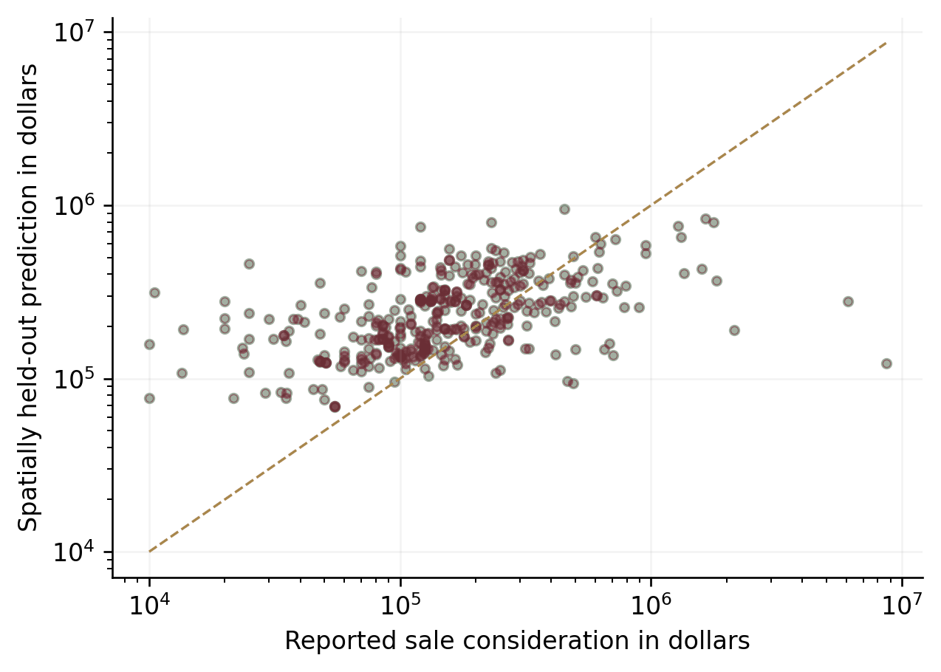
Figure 7. Predicted versus reported consideration in five spatially held-out folds. Both axes are logarithmic; the dashed line is equality. Wide errors limit individual parcel valuation. Source: county sale reports and study calculations.
Candidate acreage and coordinates must fall within the fitting sample's observed marginal support, and land use must be one of the modeled codes. Supported acreage is 10–648.5 acres. This avoids obvious extrapolation but cannot guarantee local comparability or support for every joint combination of attributes. Excluded parcels remain in the county screening file with their exclusion status; being outside price support is not evidence of low ecological value.

Measure additionality at a common future endpoint
The additionality equation compares future habitat with acquisition to future habitat without it, at the same date and under the same external scenario. The physical-change equation instead compares acquired habitat in the future with habitat at the start. Keeping both equations makes clear whether the policy preserves habitat, creates it, or does both.
ΔHim,sT=g​aigqig,smT−qig,s0T.
In plain language. Compare two futures for the same parcel i. For every intersected cell g, subtract habitat under no acquisition q⁰ from habitat under rights option qᵐ, using the same endpoint T and scenario s. Multiply each difference by its area a_{ig} and add. ΔH is the additional habitat retained because of the intervention—not automatically newly created habitat.
$$G_{im,s}\left(T\right)=H_{i,s}^{m}\left(T\right)−H_{i}\left(0\right).$$
In plain language. Now compare the intervention’s future with today. G is future habitat Hᵐ at endpoint T, for parcel i and scenario s, minus initial habitat H(0). Retaining an existing stand can avoid a loss while leaving physical change G at zero. The acquisition-only model contains no restoration-created habitat.
ΔHsx,T=g∈L​agqg,sxT−qg,s0T,
In plain language. Extend the action-versus-baseline comparison to every cell g in landscape L. The complete purchase plan x can affect the habitat term q across that landscape; a_{g} weights each cell by area. ΔH_{s} is the net additional habitat at endpoint T in scenario s. This general expression can include off-site effects, but those effects were not estimated here.
g∈L​agqg,sxT−qg0≥Gmin.
In plain language. This is a separate minimum-growth test. Across landscape L, multiply each cell’s area a_{g} by the difference between future habitat under plan x and starting habitat q_{g}(0). The total must reach G_{min}, the required physical gain. Here s identifies the scenario and T the endpoint. A purchase-only model that maintains existing structure without restoration cannot satisfy a positive G_{min}.
Action and baseline refer to the same endpoint T. The landscape formulation also permits off-site consequences; these remain unestimated here. G measures physical change from the initial date, and Gmin is a separately chosen minimum physical gain. With no modeled restoration, positive Gmin cannot be met by the executed acquisition-only intervention.
The retrieved records cannot identify parcel-specific causal loss functions. The analysis therefore tests 0, 10, 20, and 35 percent avoided loss over 30 years as scenario assumptions, not estimated probabilities. The zero-additionality case captures a necessary counterfactual: where existing law, owner behavior, or another conservation action would preserve the same habitat anyway, acquisition adds no retained acreage in this metric.
For the illustrative 20 percent case, the constant loss intensity −ln(0.8)/30 produces comparable avoided-loss fractions of approximately 7.17 percent at 10 years, 20 percent at 30 years, and 31.06 percent at 50 years. Acquisition is assumed to prevent that specified loss while maintaining credited structure. A failure scenario can reduce action retention to the no-action level and remove the benefit entirely. These assumptions describe habitat retention, not population viability or protection from every fire and disease effect.
Table 10. Conditional additional retained habitat at 30 years
Portfolio | 0% loss avoided | 10% | 20% | 35%
Recent records, either ceiling | 0.00 | 11.51 | 23.02 | 40.28
Historical records, $18m | 0.00 | 205.51 | 411.01 | 719.27
Historical records, $50m | 0.00 | 330.64 | 661.28 | 1,157.23
Acres. All fractions are assumptions. Physical gain relative to today remains zero when acquisition only maintains existing habitat.
The historical regional 21.2 percent decline provides context; it is not inserted into a parcel forecast. Observed 2017–2025 canopy change is also descriptive, not a causal treatment effect or a prediction of an unmade purchase. It may reflect several ecological or measurement processes. The executed acquisition-only model has zero restoration-created habitat. Consequently, a strictly positive required physical-gain constraint is infeasible without adding a restoration trajectory.

Buy whole parcels and credit connected habitat
Secondary-screen cells are converted to four-neighbor connected polygons and intersected with parcels to form internally connected habitat components. Existing conservation interests are handled separately. Two components are graph neighbors only if they share a positive-length boundary; touching at a corner is insufficient. Primary-screen acreage in each component is measured by fractional cell intersections. Connectivity therefore comes from screened habitat, not parcel centroids or shared tax boundaries alone.
The rooted-flow model makes each private component available only when its whole parcel is selected. A source arc exists only where a component overlaps the relevant occurrence footprint. A private root requires purchase and payment for its parcel; a conditional public root relies on mapped protected interests. Every credited private node consumes one unit of artificial flow through active connected nodes. That flow proves graph reachability—it does not predict squirrel movement.
yvm≤xivm, yvm≤uvm, zv=m​yvm≤1.
In plain language. A patch v can count under rights option m only if its parcel i(v) is selected (x) and the option is habitat-compatible (u). The y switch records that eligible patch-option choice. z adds those choices for the patch and caps the total at one, preventing duplicate credit. The executed runs price only fee-simple purchase.
$$0≤f_{ab}≤Nz_{a}, f_{ab}≤Nz_{b} \left(\left(a,b\right)∈E\right).$$
In plain language. Bookkeeping flow f travels along directed connections (a, b) in graph E. It cannot be negative or pass through a node whose active switch z is zero. N is the graph-capacity bound—not a number of squirrels. Both ends of a connection must be active before it can carry flow.
a:a,v∈E​fav−b:v,b∈E​fvb=zv v∈V.
In plain language. At each private patch v in set V, incoming flow minus outgoing flow must equal its active switch z_{v}. An active patch therefore consumes one bookkeeping unit, checking that it can be reached from a permitted starting point through active connections. f records this artificial flow; the sums add incoming and outgoing connections in E. This is not a forecast of animal movement.
a:a,r∈E​far−b:r,b∈E​frb=0 r∈R.
In plain language. At each mapped protected node r in set R, incoming flow equals outgoing flow: nothing is consumed there. It can pass a connection onward without adding privately acquired habitat credit. f is the artificial flow on connections in E. Here R means protected nodes—not reserve or restoration spending—and their status remains conditional on the mapped-interest assumptions.
b:s,b∈E​fsb−a:a,s∈E​fas=v∈V​zv.
In plain language. The artificial source s supplies exactly the flow consumed by active private patches. The right-hand sum adds their z switches over set V; the left subtracts returning flow from outgoing flow f along connections in E. Together with the preceding rules, this checks rooted paths. Here s is a graph source, not a cost or habitat scenario.
In these protocol equations, i indexes parcels, m rights alternatives, v habitat components, and (a,b) directed graph arcs. Binary x selects a parcel alternative; y credits a component under that alternative; u indicates habitat compatibility; z indicates active component availability. The nonnegative f variables carry artificial connectivity flow, N is the graph-node capacity bound, V denotes private components, R denotes public protected nodes, and s denotes the artificial source. Only one fee-simple alternative is priced in the executed runs. Public components can transmit flow without adding privately acquired habitat credit.
Graph reachability is limited by source geometry, the 30-meter raster, and the lack of field-confirmed barriers. A road or sub-grid gap may break real crown continuity without breaking the graph; a strict screen may also miss a functioning route. “Connected” therefore means connected within the screening graph. Field checks must inspect the route itself, not just distance to an occurrence feature.
A separate fixed-portfolio test removes 15-meter and 30-meter half-width buffers around mapped major roads. It caused no habitat reduction in the recent-record set; the verification archive records the result. The test does not represent unmapped roads, actual crown gaps, traffic, or field-measured permeability. [20]

Solve the portfolio, then independently check the result
After unreachable components are removed, the recent-record problem contains 155 parcel variables, 55 root-reachable component variables, and 92 flow variables. The historical problem contains 902 parcel variables and a larger graph. Binary parcel and component variables enforce whole-unit selection; continuous nonnegative flow enforces rooted reachability. Candidate overlaps are checked, with constraints against duplicate acquisition credit where overlap is material.
Each ceiling is solved independently using the same input versions. A second optimization then minimizes cost while preserving the first solution's habitat value, removing gratuitous zero-benefit purchases without changing the primary objective. Recent-record runs have a reported primary objective gap of zero. Historical runs meet the requested 0.1 percent relative-gap tolerance, with feasible values and objective bounds retained. “Optimal” is interpreted within that numerical tolerance, not as an exact-arithmetic proof of a zero-gap global optimum.
Budget totals are recalculated outside the solver in integer cents. Selected positive-benefit components receive an independent path-to-active-root check, and whole-parcel costs are charged once even when several components contribute. Scripts, membership schedules, active-node lists, bounds, runtimes, and constraint checks are preserved so that a changed price, survey, or rights package can be evaluated reproducibly.
The recent-record frontier is a separate exhaustive comparison of all 32,768 subsets of the 15-parcel maximum-habitat set. Reachability is recalculated for each subset before measuring benefit and finding the cheapest sets that meet retention targets. This is not a sort of parcel benefit-cost ratios. The domain is restricted because a different purchase package or newly eligible connecting parcel could change the frontier.

Appendix C. Results and fixed-portfolio sensitivity

Budget capacity and diminishing returns
The recent-record portfolio is unchanged between ceilings, so this particular increase in budget capacity yields zero additional screened habitat. The historical-record comparison adds 1,251.32 screened acres. That is 39.10 acres per additional million dollars of ceiling, or 43.47 acres per additional million dollars of actual modeled spending. Both denominators are reported: reserves, unspent capacity, and indivisible purchase units can make them differ.
Hx=i​m​ximΔHim, Cx=i​m​ximCim.
In plain language. Make two totals for purchase plan x: habitat H from selected parcel-rights options, and expenditure C from those same choices. The indices i and m identify parcels and options. The protocol writes benefit as ΔH; the reported base results use connected screened acreage. An explicit avoided-loss fraction converts that acreage into conditional additional retention.
$$CE\left(x\right)={10}^{6}\frac{H\left(x\right)}{C\left(x\right)}.$$
In plain language. Divide habitat H by expenditure C for plan x, then multiply by one million (10⁶). CE is habitat acres per million dollars of modeled spending—not dollars of benefit per dollar spent. Its interpretation depends on whether H means screened habitat or explicitly calculated additional retained habitat.
$$\frac{F\left(50,000,000\right)−F\left(18,000,000\right)}{32,000,000}$$
In plain language. F(B) is the optimized habitat total at ceiling B. Subtract the $18 million result from the $50 million result and divide by the $32 million increase in ceiling. This gives additional habitat per extra budget dollar. It differs from using the change in actual spending, because reserves and unspent capacity remain.
These expressions distinguish total habitat H, expenditure C, habitat per million dollars CE, and the finite difference in the optimal objective F between budget ceilings. In this study, H means credited screened habitat unless a conditional additionality fraction is explicitly applied.
Table 11. All executed optimization runs
Scenario | Parcels | Credited acres | Constraint $m | Base initial $m | Solver gap
Recent 18m base | 15 | 115.09 | 7.18 | 7.18 | 0.0000%
Recent 50m base | 15 | 115.09 | 7.18 | 7.18 | 0.0000%
Recent 18m high cost | 15 | 115.09 | 10.61 | 7.18 | 0.0000%
Recent 50m high cost | 15 | 115.09 | 10.61 | 7.18 | 0.0000%
Recent 50m staged | 15 | 115.09 | 7.18 | 7.18 | 0.0000%
Recent 18m lifecycle | 15 | 115.09 | 8.97 | 7.18 | 0.0000%
Recent 50m lifecycle | 15 | 115.09 | 8.97 | 7.18 | 0.0000%
Historical 18m base | 45 | 2,055.06 | 16.19 | 16.19 | 0.0538%
Historical 50m base | 124 | 3,306.38 | 44.98 | 44.98 | 0.0115%
Historical 18m high cost | 30 | 1,666.41 | 16.11 | 10.95 | 0.0583%
Historical 50m high cost | 85 | 2,857.63 | 44.98 | 30.52 | 0.0442%
Historical 50m staged | 124 | 3,306.38 | 44.98 | 44.98 | 0.0046%
Historical 18m lifecycle | 37 | 1,799.75 | 16.20 | 12.84 | 0.0999%
Historical 50m lifecycle | 102 | 3,107.36 | 44.99 | 37.61 | 0.0105%
Constraint spending uses high land prices in high-cost runs and capital plus 30-year stewardship PV at 3% in lifecycle runs. Staged runs retain the respective $18m base parcels. A zero gap is numerical solver output.

Complete base portfolio parcel schedule
The following schedule contains every parcel in the union of the historical-record base portfolios. Habitat credit is the contribution in the $50 million run where selected; credit in the smaller run may differ with the active path. Costs are initial base estimates, not offers. The electronic schedule retains both run-specific values, legal-description strings, source attributes, and sensitivity-run memberships.
Table 12. All historical base portfolio parcels
Map ID | County parcel ID | Land acres | Initial cost | Credited acres | Ceiling $m
H006 | 02130600000100 | 82.71 | $386,980 | 35.45 | 18 & 50
H007 | 02130600000200 | 209.75 | $800,197 | 48.61 | 50
H015 | 03111900000100 | 272.70 | $1,109,144 | 44.18 | 50
H025 | 03120800000100 | 472.63 | $648,755 | 48.17 | 18 & 50
H043 | 03121800000000 | 623.17 | $1,187,651 | 40.44 | 50
H079 | 03131000000100 | 80.13 | $358,418 | 12.47 | 50
H083 | 03132000000100 | 38.27 | $526,933 | 17.57 | 50
H089 | 03132900000100 | 77.82 | $336,687 | 17.87 | 50
H091 | 03133000000200 | 79.64 | $339,408 | 11.04 | 50
H094 | 03133000000500 | 300.26 | $883,088 | 58.12 | 50
H095 | 03133100000100 | 79.80 | $383,625 | 22.81 | 50
H098 | 03133100001000 | 79.83 | $636,350 | 17.55 | 50
H099 | 03133100001100 | 119.16 | $421,594 | 31.13 | 18 & 50
H100 | 03133200000100 | 441.15 | $936,118 | 55.20 | 50
H102 | 03133200000300 | 72.39 | $381,105 | 22.12 | 50
H149 | 04131100000200 | 326.14 | $487,424 | 11.43 | 50
H150 | 04131200001300 | 39.15 | $291,034 | 11.53 | 50
H151 | 04131200001400 | 38.99 | $290,943 | 16.93 | 50
H152 | 04131200001500 | 38.95 | $292,684 | 26.85 | 18 & 50
H153 | 04131200001600 | 39.01 | $291,177 | 12.98 | 50
H170 | 04132200001800 | 115.46 | $395,352 | 26.34 | 50
H181 | 04132900000100 | 41.40 | $315,267 | 16.65 | 18 & 50
H182 | 04132900000200 | 159.97 | $721,136 | 48.64 | 50
H183 | 04132900000400 | 124.40 | $417,821 | 59.41 | 18 & 50
H185 | 04132900000600 | 56.50 | $339,259 | 11.16 | 50
H190 | 04133200001100 | 18.92 | $244,920 | 8.99 | 50
H205 | 04140700001200 | 133.05 | $372,253 | 23.16 | 50
H210 | 04140900000300 | 88.60 | $555,519 | 20.59 | 50
H233 | 04141300000600 | 39.49 | $425,255 | 20.97 | 50
H251 | 04142000000700 | 36.42 | $246,312 | 7.03 | 50
H267 | 04142800000800 | 58.18 | $268,122 | 3.75 | 50
H271 | 04142800001300 | 19.42 | $208,821 | 6.24 | 50
H272 | 04142900000600 | 79.23 | $328,475 | 33.49 | 18 & 50
H273 | 04142900000700 | 19.69 | $239,172 | 8.38 | 50
H274 | 04142900000800 | 39.48 | $278,254 | 21.72 | 18 & 50
H275 | 04142900000900 | 19.78 | $237,298 | 13.53 | 50
H277 | 04142900001500 | 9.88 | $206,897 | 8.23 | 50
H278 | 04142900001600 | 9.87 | $207,440 | 7.21 | 50
H283 | 04143000000300 | 40.00 | $283,612 | 15.34 | 50
H299 | 04150400000300 | 82.10 | $282,333 | 16.38 | 50
H321 | 04151800000200 | 20.26 | $191,986 | 3.85 | 50
H323 | 04151900000300 | 168.63 | $347,540 | 32.63 | 18 & 50
H325 | 04151900000600 | 21.15 | $213,329 | 4.74 | 50
H326 | 04152000000500 | 47.68 | $231,164 | 16.89 | 18 & 50
H329 | 04152007600200 | 20.20 | $187,556 | 4.85 | 50
H355 | 04160130000900 | 19.96 | $152,125 | 8.45 | 50
H388 | 04161200000100 | 19.92 | $151,315 | 12.25 | 18 & 50
H485 | 05130100000100 | 444.35 | $499,351 | 145.92 | 18 & 50
H486 | 05130200000100 | 347.22 | $480,713 | 112.20 | 18 & 50
H487 | 05130300000200 | 514.24 | $539,371 | 128.45 | 18 & 50
H496 | 05132400000300 | 152.73 | $395,629 | 26.87 | 50
H502 | 05140200000000 | 568.39 | $479,084 | 14.37 | 50
H504 | 05140300000000 | 500.39 | $473,022 | 26.29 | 50
H507 | 05140400000000 | 250.79 | $415,764 | 63.41 | 18 & 50
H508 | 05140400000100 | 167.58 | $366,626 | 8.96 | 50
H509 | 05140400000200 | 167.86 | $368,438 | 15.54 | 50
H510 | 05140400000300 | 83.85 | $316,184 | 11.14 | 50
H512 | 05140500000400 | 19.03 | $236,084 | 11.77 | 50
H513 | 05140650000100 | 22.86 | $222,960 | 11.08 | 50
H534 | 05141300000200 | 161.26 | $576,899 | 29.77 | 50
H537 | 05141400000100 | 158.13 | $583,254 | 21.45 | 50
H540 | 05141400000400 | 80.72 | $300,939 | 15.31 | 50
H541 | 05141400000500 | 81.82 | $301,075 | 20.61 | 50
H551 | 05142300000300 | 81.72 | $301,225 | 22.55 | 50
H556 | 05142352000400 | 26.69 | $236,396 | 12.22 | 50
H560 | 05142500000100 | 197.81 | $365,728 | 17.04 | 50
H561 | 05142500000400 | 158.56 | $347,358 | 16.88 | 50
H563 | 05143100000700 | 157.61 | $392,180 | 47.38 | 18 & 50
H605 | 05152600000200 | 138.12 | $305,350 | 6.42 | 50
H623 | 05153000000300 | 101.74 | $506,594 | 36.85 | 18 & 50
H633 | 05153300000100 | 79.88 | $456,483 | 14.19 | 50
H641 | 05161500000000 | 631.35 | $394,504 | 8.28 | 50
H642 | 05161600000000 | 648.41 | $402,757 | 64.10 | 18 & 50
H648 | 05161900000500 | 40.45 | $219,771 | 13.36 | 18 & 50
H652 | 05162100000100 | 565.36 | $389,831 | 15.05 | 50
H656 | 05162200000300 | 153.26 | $251,037 | 28.02 | 18 & 50
H680 | 05163000000900 | 116.47 | $280,763 | 23.64 | 18 & 50
H690 | 05163300002100 | 13.51 | $147,634 | 3.41 | 50
H691 | 05163322120200 | 49.87 | $221,105 | 6.77 | 50
H709 | 05171300000800 | 22.81 | $152,329 | 8.35 | 50
H710 | 05171300000900 | 23.52 | $152,535 | 9.13 | 50
H711 | 05171300001000 | 26.24 | $155,537 | 10.03 | 50
H739 | 05172056000800 | 19.83 | $145,676 | 9.93 | 18 & 50
H740 | 05172056000900 | 20.18 | $145,383 | 9.13 | 50
H741 | 05172056001000 | 19.68 | $145,370 | 11.28 | 18 & 50
H743 | 05172056001500 | 28.36 | $157,424 | 10.10 | 50
H768 | 05172951000700 | 20.45 | $145,372 | 3.39 | 50
H769 | 05172951000800 | 20.91 | $146,173 | 3.68 | 50
H773 | 05172958000100 | 19.67 | $146,371 | 14.16 | 18 & 50
H774 | 05172958000300 | 20.00 | $145,601 | 15.50 | 18 & 50
H793 | 05173271000800 | 20.96 | $147,631 | 5.31 | 50
H799 | 05181800000300 | 31.05 | $144,537 | 7.32 | 50
H837 | 05201700000200 | 159.34 | $290,245 | 11.79 | 50
H847 | 06133500000000 | 638.15 | $562,371 | 128.08 | 18 & 50
H851 | 06142700000000 | 653.25 | $503,671 | 59.20 | 18 & 50
H852 | 06142800000100 | 277.33 | $417,873 | 104.69 | 18 & 50
H853 | 06142800000200 | 120.19 | $571,254 | 13.68 | 50
H854 | 06142800000300 | 79.85 | $315,984 | 40.44 | 18 & 50
H855 | 06142800000400 | 79.41 | $313,448 | 33.79 | 18 & 50
H856 | 06142800000500 | 79.23 | $313,626 | 44.34 | 18 & 50
H857 | 06142900000100 | 474.57 | $810,191 | 66.68 | 18 & 50
H858 | 06142900000200 | 159.46 | $374,162 | 70.89 | 18 & 50
H859 | 06143100000100 | 108.80 | $317,447 | 8.03 | 50
H860 | 06143200000100 | 79.39 | $320,806 | 23.11 | 18 & 50
H861 | 06143200000200 | 78.95 | $323,409 | 7.51 | 18 & 50
H862 | 06143200000600 | 20.05 | $234,183 | 4.75 | 50
H863 | 06143200000700 | 20.06 | $234,250 | 7.59 | 50
H864 | 06143200001100 | 160.05 | $378,919 | 24.82 | 50
H865 | 06143200001200 | 80.30 | $320,622 | 31.92 | 18 & 50
H867 | 06143300000000 | 328.18 | $432,432 | 93.78 | 18 & 50
H868 | 06143300000100 | 81.10 | $313,412 | 28.83 | 18 & 50
H869 | 06143300000200 | 80.32 | $315,707 | 35.94 | 18 & 50
H870 | 06143300000300 | 77.15 | $315,539 | 44.61 | 18 & 50
H871 | 06143300000400 | 79.57 | $315,909 | 40.03 | 18 & 50
H872 | 06143400000000 | 648.79 | $504,943 | 15.68 | 50
H873 | 06143500000000 | 634.40 | $494,280 | 20.13 | 50
H874 | 06143600000000 | 632.09 | $483,968 | 62.42 | 18 & 50
H875 | 06191900000200 | 375.69 | $399,931 | 30.96 | 18 & 50
H877 | 06192000000200 | 352.73 | $390,984 | 9.90 | 50
H878 | 06192000000400 | 158.91 | $327,221 | 39.93 | 18 & 50
H883 | 06192900000100 | 158.47 | $323,306 | 23.17 | 18 & 50
H884 | 06192900000200 | 320.25 | $385,327 | 17.16 | 50
H885 | 06192900000300 | 160.89 | $323,571 | 10.34 | 50
H886 | 06193000000100 | 118.47 | $308,754 | 12.29 | 50
124 distinct parcels. The 45-parcel $18m base set is contained in the $50m base set. Electronic files retain unrounded numbers and all sensitivity-run memberships.
Historical-record concentrations can reveal attractive connected purchase opportunities, but their interpretation depends on the age and geography of the occurrence roots. Current habitat and squirrel use must still support the assumed connection. The full schedules retain occurrence distances, canopy change, total screened habitat, root-reachable habitat, price basis, and disturbance overlaps so that field teams can trace why each parcel was selected.

Stress-test fixed sets before re-optimizing
Each base portfolio is tested under common cost and habitat-classification settings before any alternative set is optimized. The high-price test raises land consideration by 50 percent without changing parcels. Strict and relaxed habitat tests change the primary rule inside the original selected connected components; they do not rebuild the graph or introduce new connections. These are conditional classification contrasts, not statistical confidence bounds.
Table 13. Fixed base portfolio stress results
Portfolio | Strict acres | Base acres | Relaxed acres | Price +50% cost
Recent records, either ceiling | 49.64 | 115.09 | 227.43 | $10.61 million
Historical records, $18m | 860.83 | 2,055.06 | 3,245.70 | $23.85 million
Historical records, $50m | 1,383.44 | 3,306.38 | 5,847.19 | $66.29 million
Same selected components and parcels in each row. Strict and relaxed habitat rules alter classification within the original connection support; they do not reconstruct every possible ecological route.
No selected recent-record parcel overlaps an active forest-practice application in the retrieved overlay. Imminent harvest is therefore not demonstrated for that set, although future harvest risk remains unresolved. Some historical-record selections overlap active applications, including even-aged applications. Interpreting those footprints requires application review, current imagery, timing, and a counterfactual management assessment; overlap is not certain habitat destruction.

The evidence needed for a purchase decision
The key unresolved inputs are contemporary occupancy and nest use, field habitat structure, legal purchase packages, seller participation, appraised prices, enforceable easement terms, and the future habitat difference between acquisition and no acquisition. These inputs determine whether a modeled priority delivers additional benefit and can close within budget. Recent public detections can improve where to investigate, but cannot resolve all those questions on their own. [22]
The following components remain unestimated: a fitted detection model, parcel-specific harvest probability, restoration maturation function, landscape leakage coefficient, employment multiplier, extinction-risk model, and negotiated easement value. Their equations and data requirements remain part of the research framework. Quantitative findings in this paper are limited to the components actually calculated; adding the others requires new evidence and a documented model extension.

Appendix D. Implementation and monitoring

Close the ecological and transaction gaps
For the first priority group, field teams should locate the credited habitat components, test whether their mapped connections function on the ground, and survey current squirrel use with a design that accounts for imperfect detection. Record tree species, canopy arrangement, diameter classes, potential nest structures, mast resources, shrub cover, and important barriers. Retain an incidental sighting as a dated detection rather than treating it as a population estimate.
Transaction review should identify the complete estate and every parcel that must transfer, obtain title and recorded-interest reports, establish lawful access, identify management or restoration liabilities, and confirm willingness to sell. Appraisals should use current, rights-consistent market evidence and explain timber, development, and financing adjustments. Assessor forestland values may inform fiscal estimates, not replace appraisal. Where a quoted package differs from mapped units, re-optimize using its full price and shared transaction costs.
Table 14. Conditions for releasing acquisition funds
Decision | Evidence required | Model consequence
Ecological qualification | Current use, field structure and actual connected route | Replace proxy eligibility and credit
Transaction unit | Title, complete parcel package, access and seller consent | Use full indivisible unit and constraints
Valuation | Independent appraisal and negotiated offer | Replace price prediction and stress range
Additionality | Enforceable change from credible baseline | Replace uniform avoided-loss assumption
Stewardship | Funded management, restoration and monitoring plan | Include lifecycle obligations and physical gain
Final portfolio check | Rerun with verified inputs and documented exclusions | Confirm strict affordability and connected benefit

Use the historical-record schedule to target a second survey phase. Give attention to sites selected repeatedly across budgets and price scenarios, large connected-habitat contributors, and sites with plausible disturbance concerns. Pair that targeted work with a complementary sampling design outside the existing record-conditioned footprint. Old or absent public records alone are not a reason to overlook potentially important habitat.

Integrate the recent evidence without changing the old runs
The next evidence collection should prioritize precise recent sightings, repeat-survey results, and the UW/WDFW prioritization model. The supplemental review establishes why these inputs matter; the tasks below specify how to make them usable in a reproducible acquisition analysis. No release date or completed occupancy surface is assumed. [22, 23]
For each recent sighting, preserve the source and stable record identifier, observation date rather than upload date, identification evidence, available coordinates, spatial uncertainty or obscuration, quality status, and retrieval date. Deduplicate overlapping reports and retain source-specific release conditions. Associate a detection with nearby parcels only after checking its location uncertainty and the plausible habitat route. A nearby point is supporting evidence, not proof that every neighboring parcel is occupied.
For repeat surveys, obtain authorized sampling locations, visit dates, effort, methods, detection and nondetection histories, and the sampling frame. Establish how the new design compares with 2018–2020 before estimating change. For the UW/WDFW model, obtain the relevant version, code or parameter documentation, prediction date, input layers, geographic resolution, validation information, and intended interpretation. Compare its priorities with this screen using a documented parcel crosswalk; distinguish agreement, disagreement, and different objectives rather than treating the external model as automatic certification.
Archive the resulting inputs and exclusion decisions, then run a new named scenario with its own source manifest, checksums, prices, roots, connected components, solver output, and parcel schedule. Keep the original 2018–2020 and historical-record runs available as benchmarks. That preserves the existing analysis while showing exactly what the newer evidence changes.

Monitoring outcomes and revising the portfolio
Measure baseline habitat before intervention. Retain visit-level detection histories and survey effort so that later analysis can distinguish changes in detectability from changes in occupancy. Use consistent spatial units and habitat definitions through time, record management and disturbance, and compare conditions with both the initial baseline and the stated no-acquisition trajectory.
Where practical, choose untreated or delayed-treatment comparison sites before implementation. Their usefulness depends on comparability, shared trends, spillovers, and treatment selection. A purchase followed by an observed change is not, by itself, a causal estimate. Monitoring can report descriptive changes in habitat and occupancy while separately testing whether the comparison design supports attribution.
An implementation dashboard should report actual spending, rights acquired, newly controlled habitat, verified habitat condition, restoration progress, and continuing obligations. Keep observations distinct from forecasts and retain revisions to parcel and occurrence versions. Apply the release conditions of any new agency data to sensitive locations; the current public extract does not authorize publication of future restricted records.

Research reproducibility and decision ownership
The supporting archive contains normalized candidates, precise parcel schedules, geospatial layers, raster inputs, parameters, model code, and verification records. A decision-maker can change a budget, substitute an appraisal, remove an unwilling seller, add a bundled purchase, or use an authorized occupancy dataset within the same methodology. Each change requires regenerated outputs under a new named scenario, not manual alteration of the paper's results.
The remaining policy choice is how to balance evidentiary confidence, habitat coverage, and the timing of expenditure as the inputs improve. The recommended approach is a compact first stage with a conditional expansion option—not automatic preference for the largest affordable portfolio. The implementing authority retains responsibility for objectives and transaction approval. The research provides explicit assumptions, reproducible comparisons, and identifiable land units on which to act.

Habitat and measurement uncertainty at first-stage targets
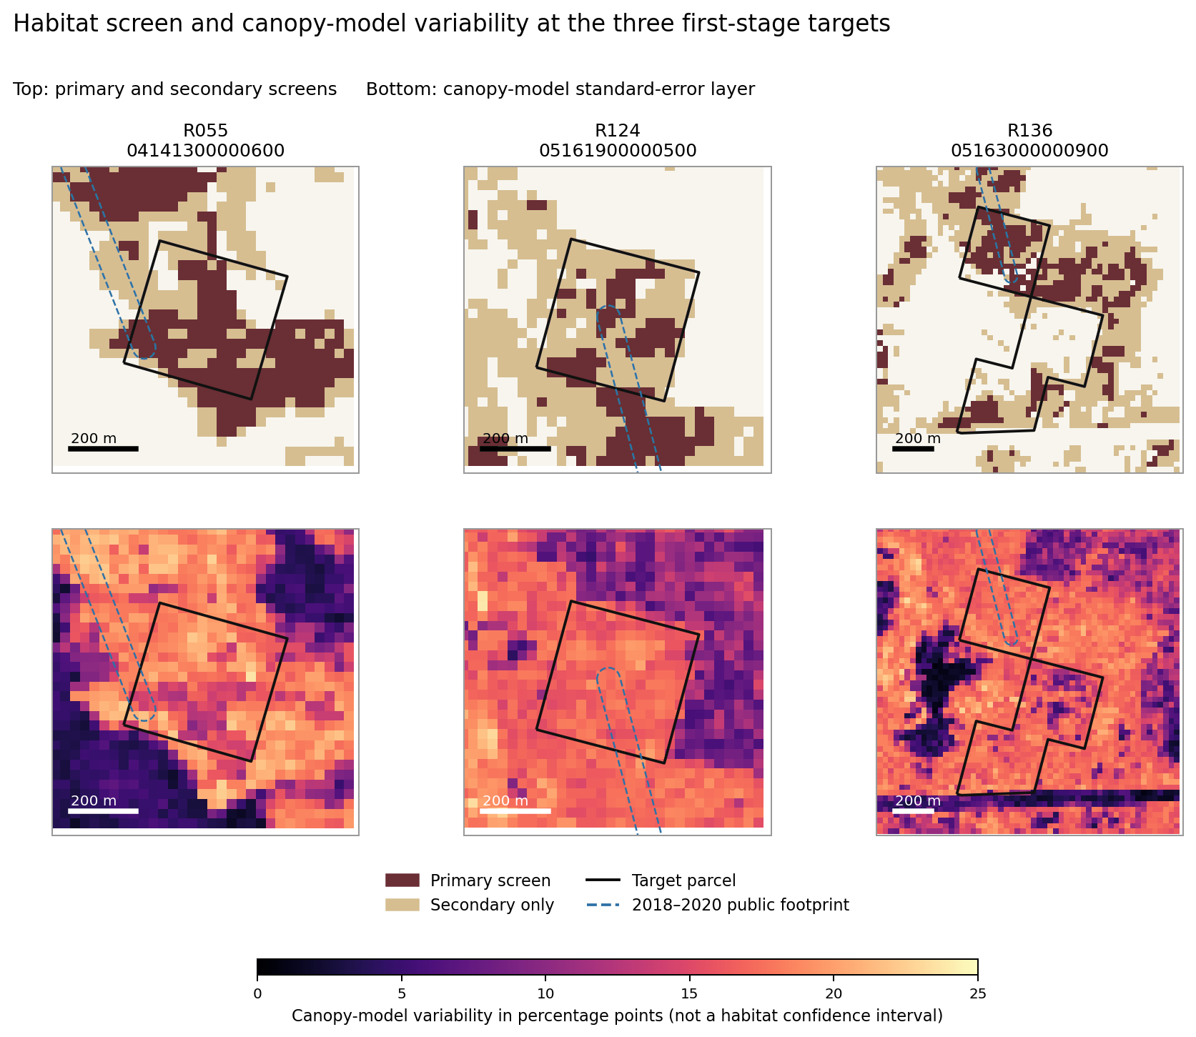
Figure 8. Habitat and input-measurement variability at the first-stage parcels. Sources: county parcels, WDFW public footprints, LANDFIRE 2025, and Forest Service TCC v2025.6. Native raster resolution is 30 m; EPSG 5070. Grid north is up. No field confirmation is implied.
The upper panels map the primary and secondary screens at the three first-stage targets. Black outlines show whole parcels; dashed blue lines show public 2018–2020 survey footprints. Lower panels display the Forest Service canopy-model variability layer for the same area. This locates uncertainty in a remotely measured input rather than estimating a confidence interval for habitat suitability or occupancy. Field work should compare these classifications with actual stand structure and connected routes.

References
The original web and dataset snapshot is 19 September 2026; archived requests and hashes identify its versions. References [1]–[21] are retained from the supplied analysis. Reference [22] identifies the supplemental evidence statement supplied for this revision, and [23] identifies the agency report on the prioritization work. Neither update has been incorporated into a new numerical portfolio run.
[1] Scott, Benny. Undated. Western gray squirrel habitat policy brief. Edict Economics. User-supplied source document; retained in the archive.
[2] WGS Klickitat Complete Research Protocol. 18 September 2026. User-supplied research specification; retained in the archive.
[3] Wiles, G. J., D. W. Stinson, and M. J. Linders. 2023. Periodic status review for the western gray squirrel in Washington. Washington Department of Fish and Wildlife. https://wdfw.wa.gov/sites/default/files/publications/02410/wdfw02410.pdf
[4] Linders, M. J., and D. W. Stinson. 2007. Washington State recovery plan for the western gray squirrel. Washington Department of Fish and Wildlife. https://wdfw.wa.gov/sites/default/files/publications/00119/wdfw00119.pdf
[5] Linders, M. J., W. M. Vander Haegen, J. M. Azerrad, R. Dobson, and T. Labbe. 2010. Management recommendations for Washington’s priority habitats and species: western gray squirrel. WDFW. https://wdfw.wa.gov/sites/default/files/publications/00027/western_gray_squirrel_final.pdf
[6] Washington Department of Fish and Wildlife. Western gray squirrel species account. Current state listing and threats. https://wdfw.wa.gov/species-habitats/species/sciurus-griseus
[7] Washington Department of Fish and Wildlife. PHS on the Web public species polygons, MapServer layer 3. Filter: western gray squirrel. https://geodataservices.wdfw.wa.gov/arcgis/rest/services/PHSOnTheWeb/PHSOnTheWebPublic/MapServer/3
[8] Klickitat County. Parcel Information Online and linked county iMap parcel service. Layer 6; native field PARCEL_NUM. https://www.klickitatcounty.gov/213/Parcel-Information-Online
[9] Klickitat County Assessor. Sales Reports. Unimproved sales spreadsheets for 2021–2026; 2026 file posted as August report. Exact download URLs are in the source manifest. https://www.klickitatcounty.gov/229/Sales-Reports
[10] USDA Forest Service. Science Tree Canopy Cover, release v2025.6; 2025 and 2017 cover and 2025 standard-error layers. Methods and metadata. https://data.fs.usda.gov/geodata/rastergateway/treecanopycover/docs/TCC_v2025-6_Methods.pdf
[11] LANDFIRE. LF2025 CONUS Existing Vegetation Type, Height, and Cover image services and class legends. https://lfps.usgs.gov/arcgis/rest/services/Landfire_LF2025
[12] Washington Department of Natural Resources. Public Forest Practices Application harvest units, layer 6. https://gis.dnr.wa.gov/site2/rest/services/Public_Forest_Practices/WADNR_PUBLIC_FP_FPA/MapServer/6
[13] US Geological Survey. Protected Areas Database of the United States, served fee-manager layer PADUS4_1FeeManagers. https://services.arcgis.com/v01gqwM5QqNysAAi/arcgis/rest/services/Fee_Managers_PADUS/FeatureServer/0
[14] US Geological Survey. Protected Areas Database of the United States, served protection-mechanism layer PADUS4_1ProtMechCat; easement category. https://services.arcgis.com/v01gqwM5QqNysAAi/arcgis/rest/services/Protection_Mechanism_Category_PADUS/FeatureServer/0
[15] US Forest Service and US Geological Survey. Monitoring Trends in Burn Severity fire boundaries and program scope. https://www.mtbs.gov/faqs
[16] Washington Department of Natural Resources. Lidar project coverage index, August 2026 service. Coverage footprint audit only. https://services.arcgis.com/4x406oNViizbGo13/arcgis/rest/services/dnr_lidar_index_August2026/FeatureServer/0
[17] US Environmental Protection Agency. 2024. Guidelines for Preparing Economic Analyses, third edition. https://www.epa.gov/environmental-economics/guidelines-preparing-economic-analyses-3rd-edition
[18] Washington State Legislature. RCW 77.12.203, payments in lieu of real property taxes; applicability and county election provisions. https://app.leg.wa.gov/RCW/default.aspx?cite=77.12.203
[19] Klickitat County Assessor. Designated Forest Land. Assessment program description. https://www.klickitatcounty.gov/179/Designated-Forest-Land
[20] Klickitat County iMap. Major-road geometry, Layers MapServer layer 2. https://geo.gartrellgroup.com/server/rest/services/Klickitat/Layers/MapServer/2
[21] National Interagency Fire Center. WFIGS Interagency Perimeters Current, public feature service layer 0. Retrieval-date context query; not an exhaustive annual fire inventory. https://services3.arcgis.com/T4QMspbfLg3qTGWY/arcgis/rest/services/WFIGS_Interagency_Perimeters_Current/FeatureServer/0
[22] Edict Economics. 19 September 2026. Supplemental public-presence evidence statement supplied with the revision instructions: recent public records, the absence of a complete contemporary occupancy surface in the sources located, and priorities for precise sightings, repeat-survey results, and the UW/WDFW prioritization model. Author-supplied research update; not an input to the original numerical runs.
[23] Washington Department of Fish and Wildlife / Washington Department of Natural Resources. 2026. Western gray squirrel annual report to the Forest Practices Board, covering the 2025 FPA/N permit period. August 2026 Board materials. Public report identifying the UW spatial-prioritization project and delivery of model parameters and code on 21 July 2025. https://dnr.wa.gov/sites/default/files/2026-08/bc_fpb_wgs2025_rpttofpb_final.pdf

